United States Map, 1861
Union (The North) – Blue Confederacy (The South) – Grey Territories (The West) - Green
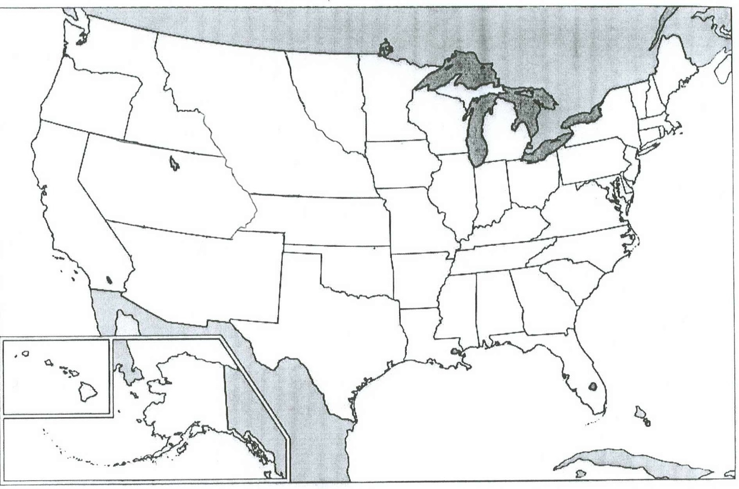

United States Map, 1861
Union (The North) – Blue Confederacy (The South) – Grey Territories (The West) - Green
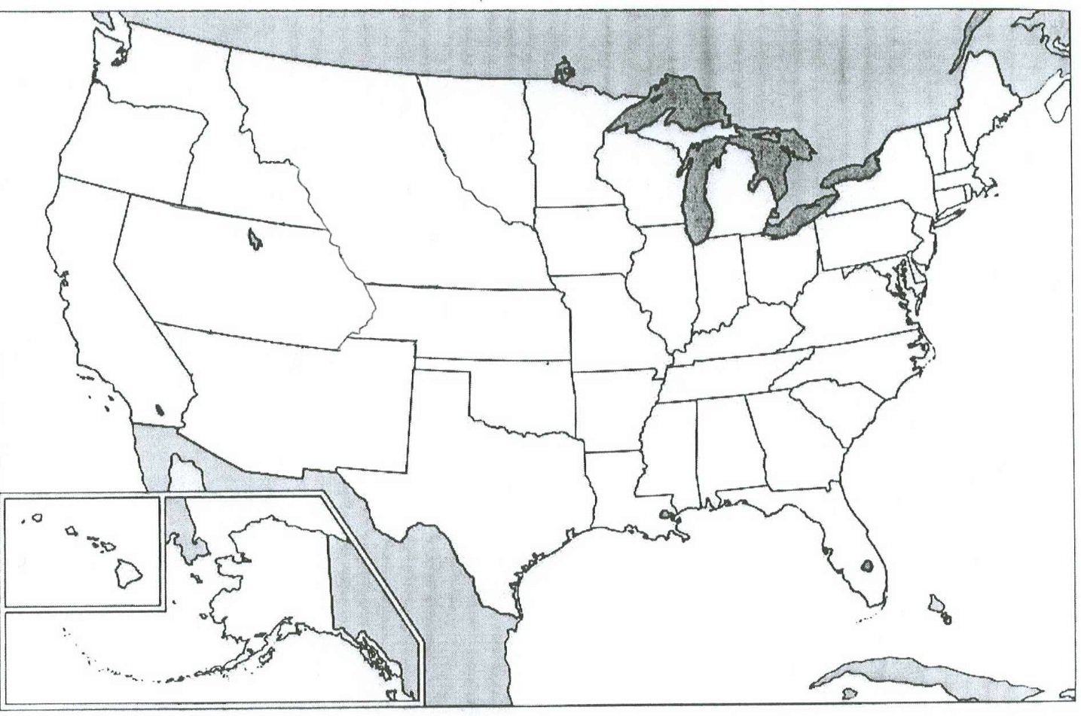

Directions: Use your prior knowledge and the map to answer the following questions. Give complete answers.

1) What are some physical characteristics that would be different between the 3 sections/regions of the United States?

2) How might that affect the human characteristics in those areas?

3) What role do you think the territories played in the U.S. at this time?

Directions: Use your prior knowledge and the map to answer the following questions. Give complete answers.

1) What are some physical characteristics that would be different between the 3 sections/regions of the United States?

2) How might that affect the human characteristics in those areas?

3) What role do you think the territories played in the U.S. at this time?

