Name: __________________________________ Class Period: ___________ Brame MYP/Vanguard Texas History Date: _____________________

4 Regions DBQs
Directions: Analyze the following sources and answer the document based questions that follow.

Document #1 – Maps of Texas
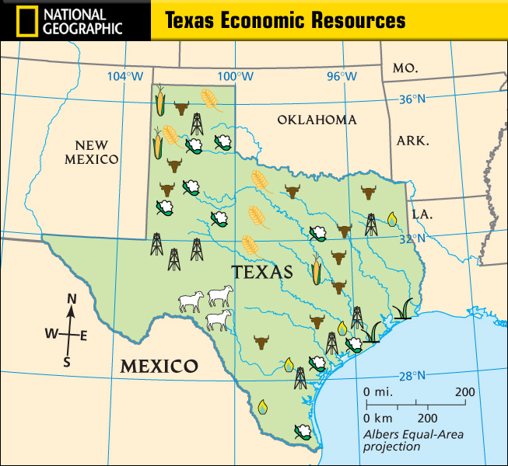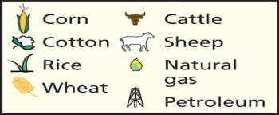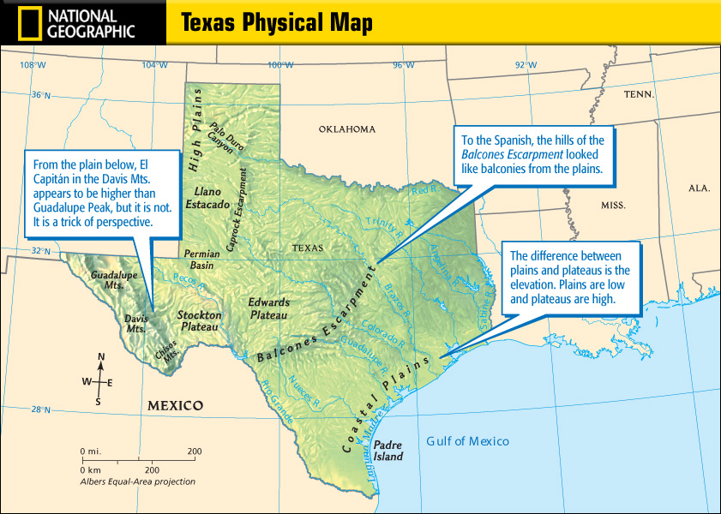
1) Based on the economic resources above, which regions do you believe will have rural communities? Explain.______________________________________
____________________________________________________________________________________________________________________________________________________________________________________________________________________________________________________________________
2) Rice is only grown by the Gulf of Mexico. What conclusion can you draw about this type of crop? _________________________________________________
____________________________________________________________________________________________________________________________________________________________________________________________________________________________________________________________________
3) What part of Texas has very little to no economic resources? Why do you think that is (think physical and human features)? ____________________________ __________________________________________________________________________________________________________________________________
__________________________________________________________________________________________________________________________________
4) Compare the two maps. What connections can you make between physical features and resources in Texas? Give examples. __________________________________________________________________________________________________________________________________
__________________________________________________________________________________________________________________________________
__________________________________________________________________________________________________________________________________

Document #2 – Excerpt about Texas
Texas often has hurricanes that are spawned over the ocean or the gulf and then land at the Texas coast and travel inland. The destruction created by hurricanes can be traced to excessive precipitation which causes flooding of both land and home; tidal waves and strong wave action destroy the coastline; strong winds create storm surges and damage to physical structures; and tornados created by converging weather patterns are generated at the edge of hurricane activity. All of these actions create a series of natural disasters that are costly to the state of Texas and Texans.

1) How do hurricanes affect Texas? Which region would be affected? __________________________________________________________________________
__________________________________________________________________________________________________________________________________
2) What are adaptations humans can make to prior to these natural disasters? ____________________________________________________________________
____________________________________________________________________________________________________________________________________________________________________________________________________________________________________________________________________
3) Explain how the hurricane activity can affect movement with Texas. _________________________________________________________________________
____________________________________________________________________________________________________________________________________________________________________________________________________________________________________________________________________
4) What are some modifications/adaptations that could be made to lessen the damage mentioned in the excerpt? ________________________________________
______________________________________________________________________________________________________________________________________________________________________________________________________________________________________________________________________________________________________________________________________________________________________________________________________

