Statehood

What are some of the issues the Republic of Texas faced? How could they be solved?
_________________________________________________________________________________________________________________________
_________________________________________________________________________________________________________________________
_________________________________________________________________________________________________________________________

Nation Divided
- Sectionalism – excessive _______________________ to a region or section, creating _______________________.
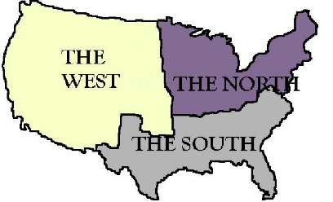
- 1836 – Texas was a ____________-________________ state and would tip the balance of power in Congress
  - North – __________________
  - South – ________
  - West – Undecided, mostly territories

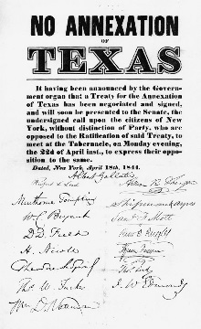
Attempts at Annexation
- ___________ – Texans vote for it/U.S. turns them down
- 1844 – The Republic and U.S. Congress draft a _______________ to make Texas a _________________________
  - Texans _____________________ it
  - U.S. _____________________ it again
Why would the U.S. reject the annexation of Texas? ___________________________________________________________
_________________________________________________________________________________________________________________________
_________________________________________________________________________________________________________________________

Why not Texas?
- U.S. would get public _______________ to sell to pay off Texas’s huge _______________
- Would add Texas as a __________________________, not a state
- _________________ does not want a _________________ state
- Afraid of causing a war with _________________
- Wanted to avoid controversy with their __________________________________ (voters back home) during an election year
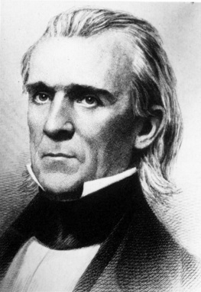
James Polk
- Was elected the ____________ U.S. president in 1844
- Wanted to annex Texas
- Why??????
  - _____________ the U.S.
  - _______________________ from the South

Annexation
- Congress decided to pass a ______________ _________________________ [passed in both houses of congress] for annexation.
- The joint resolution contained terms more favorable to Texas than those of the treaty of ___________. Texas could…
  - Enter the U.S. as soon as its people approved annexation and adopted a state _______________________, bypassing the time Texas would have just been a ________________________
  - Keep its ___________________ lands but could sell some of it to pay off debts
  - Be ______________________ into as many as ________ states with the approval of Texas and the U.S.
- ____________________ ____________________ and the Texas ______________________________ came up with a new state constitution and overwhelmingly voted for annexation
- On Oct. 13, 1845, Texans approved annexation by a _________________ of 4,254 to 257
- On Dec. 29, 1845, President Polk _______________________ the resolution that made Texas a state

In 1845, Mexico finally recognizes Texas independence
- ___________________ and ___________________ did not want the U.S. to grow
- They convinced Mexico to recognize that Texas was _______________________________, with the condition that the Republic must ___________________ annexation
- Too late at that point, Texans just want ________________________

“The final act in this great drama is now performed: the Republic of Texas is no more.”
- On Feb. 19, 1846, at a ceremony in front of the Texas Capitol, Texas _________________________ became a state
- Anson Jones, the last Texas President, handed over Texas to the 1st __________________________________, James P. ____________________________________

