Secession
The _______________ States of America
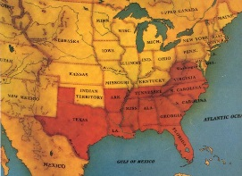

The two sides
- Unionist - a person who _________________________________________________________________.
- Secessionist - a person who ____________________________________________________________________.
Lincoln elected
- The ____________ election was strictly __________________________
- Lincoln’s name was not even on some _________________ _______________________
- Because of the election _________________________was the first state to secede on December 20th, ______.
Who followed?
- The states __________________________________, join in early 1861
- Georgia, Alabama, Louisiana, ______________________ , Florida, and Mississippi
- Then 4 more joined once the Confederacy declares war
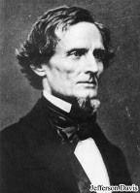
- Arkansas, North Carolina, __________________________, and Tennessee
Texas Votes
- At the convention the delegates voted 166 to 8 for secession from the Union.
Confederate President
- _______________________________________ leaves the US Senate to become the president of the Confederacy

Secession
The _______________ States of America

The two sides
- Unionist - a person who _________________________________________________________________.
- Secessionist - a person who ____________________________________________________________________.
Lincoln elected
- The ____________ election was strictly __________________________
- Lincoln’s name was not even on some _________________ _______________________
- Because of the election _________________________was the first state to secede on December 20th, ______.
Who followed?
- The states __________________________________, join in early 1861
- Georgia, Alabama, Louisiana, ______________________ , Florida, and Mississippi
- Then 4 more joined once the Confederacy declares war
- Arkansas, North Carolina, __________________________, and Tennessee
Texas Votes
- At the convention the delegates voted 166 to 8 for secession from the Union.
Confederate President
- _______________________________________ leaves the US Senate to become the president of the Confederacy

