Name ______________________________ Period_____________________
Date _______________________________ Brame MYP Texas History

Massacre at Goliad and the Runaway Scrape
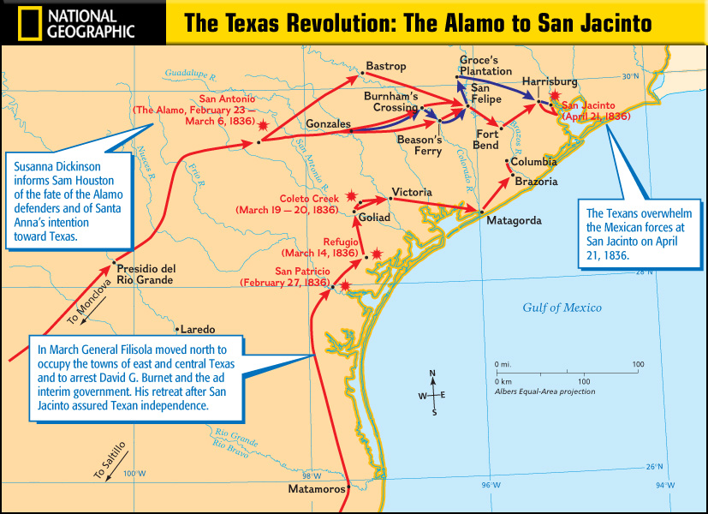

After the Alamo…
______________________________ and some Texans were in the town of Coleto Creek. Sam Houston ordered them to ______________ after the loss at the Alamo. But Fannin delayed…

Massacre at Goliad – March 27, 1836
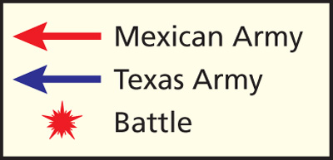
Mexican leader, General Urrea, surrounded Colonel James Fannin and the Texans at Coleto Creek. Realizing they were outnumbered, Texans ______________ at discretion. Urrea marched the Texans to the city of _______________ where Santa Anna ordered the Texans to be __________________ even though they surrendered. ________ Texans were shot at gunpoint with only a few escaping. ______________________________________ helped unite the Texans like the Alamo.

The Runaway Scrape – March 11, 1836 - April 21, 1836
After the massacres at the Alamo and Goliad,
Sam Houston ordered the Texans to ______________ east across Texas in a __________ ___________ pattern. Sam Houston was widely criticized for his decision in the Runaway Scrape. Some Texans thought of Houston as a coward while others supported him saying his strategy was genius.

Coward or Genius?

Directions: Read the following passages. For each one, decide if the document supports the idea of Sam Houston as a coward or genius, and circle your choice. Then complete the outline using direct evidence from the documents to argue that Sam Houston was either a coward or a genius. Give an explanation of why the source proves your POV. An example has been provided for you.

Document 1 – Coward or Genius (circle one)

With news of Goliad, some angry Texans began to demand an attack on Mexican forces. The Texas army had grown to more than 1,200 men after the fall of the Alamo. Houston, however, believed that his army was still too small and untrained to defeat the larger and better-supplied Mexican army.

Document 2 – Coward or Genius (circle one)
Several Texas troops openly rebelled against Houston, criticizing him for retreating. Even President Burnet [President of Texas] challenged Houston to fight. “The enemy are laughing you to scorn [disdain, contempt, or disrespect].”

Document 3 – Coward or Genius (circle one)
Sam Houston learned that Santa Anna was heading to Gonzales, where Houston had fewer than 400 men. With more than 700 Mexican troops advancing on them, the Texans were in danger. Houston ordered a retreat. Many civilians packed their belongings and left as well. Houston then ordered the town of Gonzales burned so that the Mexican troops would not take any additional supplies.

Document 4 – Coward or Genius (circle one)

As we passed through the streets of Gonzales, we noticed great lights in the houses and the people packing up their household effect in all possible haste. A man came out on the piazza [town square] and said (addressing the army), "In the name of God, gentlemen, I hope you are not going to leave the families behind!" Someone in our ranks answered [sarcastically], "O yes, we are all looking out for number one [only ourselves]."

- Kuykendall’s, a Texan solider, account of the Runaway Scrape

Name ______________________________ Period_____________________
Date _______________________________ Brame MYP Texas History

Massacre at Goliad and the Runaway Scrape

Sam Houston was a coward

- Document #2, Example Evidence: Even President Burnet [President of Texas] challenged Houston to fight. “The enemy are laughing you to scorn [disdain, contempt, or disrespect].”
Explanation: High-ranking Texas officials believed that Sam Houston was a coward by not fighting, and as a result, that Mexico viewed the Texas army as weak.

- Document # _____ Evidence #1_______________________________________________________________
___________________________________________________________________________________________
Explanation _______________________________________________________________________________
___________________________________________________________________________________________
___________________________________________________________________________________________
- Document # _____ Evidence #2_______________________________________________________________
___________________________________________________________________________________________
Explanation _______________________________________________________________________________
___________________________________________________________________________________________
___________________________________________________________________________________________

Sam Houston was a genius

- Document # _____ Evidence #1_______________________________________________________________
___________________________________________________________________________________________
Explanation _______________________________________________________________________________
___________________________________________________________________________________________
___________________________________________________________________________________________
- Document # _____ Evidence #2_______________________________________________________________
___________________________________________________________________________________________
Explanation _______________________________________________________________________________
___________________________________________________________________________________________
___________________________________________________________________________________________

