The Republic of Texas and Statehood
Review
- Texans win the _________________________ and the Revolution on April 21, 1836
- Santa Anna signs the ________________________ on May 14, 1836
- Texas becomes its own country… __________________________________________________!

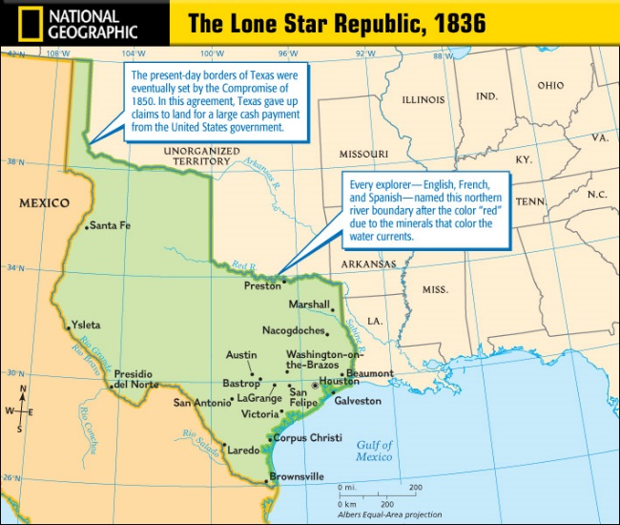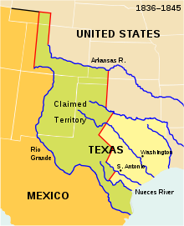
1st President - _____________________________

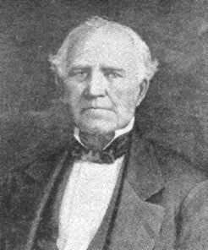
- Sam Houston is _________________________________
- 1st Term - ___________ to ___________
- Makes ___________________________the first capital
- Elected again as the _________________________ (1841-1844)

2nd President - ______________________________
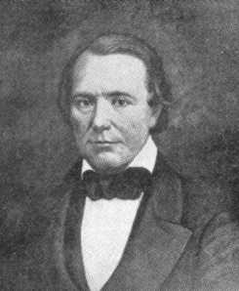
- Mirabeau Lamar is elected because ____________________________________
- Served _____________ to __________________
- Moves capital to ______________________________

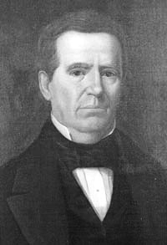
3rd President (4th term) - _____________________________________
- ___________________________________________
- That’s all you need to know about him!

The Republic of Texas - 1836-1845
Problems:

  - Unrest in the army
  - Debt (no money)
  - Native American raids
  - Border debates
  - Troubles with Mexico
  - Education
  - Getting independence recognized from other countries

What conclusion can you draw from this list of problems?

Their Policies

Houston
- Pro-annexation
- _____________________________
- Little military
- ____________________________
- Capital in Houston
- _____________________________
Lamar
- ___________________________________
- Remove the Natives
- __________________________________
- Increase paper currency
- ___________________________________
- Father of education

Protection
- Texans faced conflicts with _________________________and ________________________________
- Stephen Austin created the________________________, but they grew during the Republic
- ____________________________________ was the most famous Ranger
- Lamar believed the Texans needed a Navy, their commander was_____________________________.

Statehood – 1845- Present
  - Texas is annexed (added) to the U.S. in ______________ as the ________________________
  - Texas becomes the only state in the union to have once been a country
