Reconstruction in Texas, 1865-1870
War is over! But…
- Since the Confederacy lost the war, much of the ________________________, and money was hard to come by.
- _____________________________________ were free, but many were without food or shelter.
- Tensions and differences between many __________________ and _________________ continued after the war.

What was Reconstruction?
Reconstruction was a period of rebuilding ____________________________________________________________.

Juneteenth – 1865
- Because of distance and the war, many African Americans did not immediately learn about the ______________________________________ of 1863.
- The news finally reached ______________________________ on June 19th, 1865. _______________________ became a celebration for the freedom of enslaved Texans.

Free at Last???
- Since most slaves were uneducated and their only skill was _____________________, they often stayed in the South and worked on plantations.
- Poor whites and freed slaves would _____________________________________ from plantation owners and a large percentage of their crops were sold for profit by the landowners. Poor whites and freed slaves were left with little to sell and feed their own families.
- This was called ____________________________________, which was not much better than slavery.

The Freedman’s Bureau
- Former slaves were often referred to as ____________________________.
- The Freedmen’s Bureau was a government agency whose job was to ___________________________ to the thousands of people, black and white, who had been left homeless by the Civil War.

Two Plans for Reconstruction

Lincoln and Johnson wanted…
- To restore the ________________ as quickly as possible
- To go easy on the South, to rebuild their relationship

Congress wanted …
- Stricter standards for admitting the Southern States back into the Union
- To protect the freedom of ____________________ in the South

Southerners Oppose Reconstruction
- Texas elected ex-Confederates to Congress in an attempt to counter the _____________________________ control of Congress.
- Texan representatives refused to ratify the ____________________________________ which granted rights to African Americans.
- Southern states enforced _________________________, or laws limiting the rights of African Americans.
- The ___________________________ (KKK) used violence and threats to prevent African Americans from voting.
- As a response to Southern opposition, Congress declared military rule in the South until states met certain requirements of Reconstruction.

Reconstruction Ends
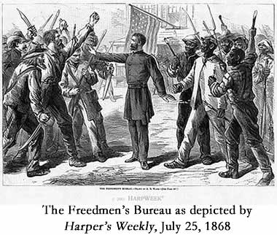
- On _____________________________, President Ulysses S. Grant signed a proclamation that Reconstruction in Texas was over. By the end of the year, all of the Southern states had rejoined the Union on the Radical Republicans’ terms.

