Name _________________________________ Date _____________
Brame MYP/Vanguard Texas History Period ____________

OPTIC: Political Cartoons
Directions: For each cartoon below use OPTIC to analyze it.
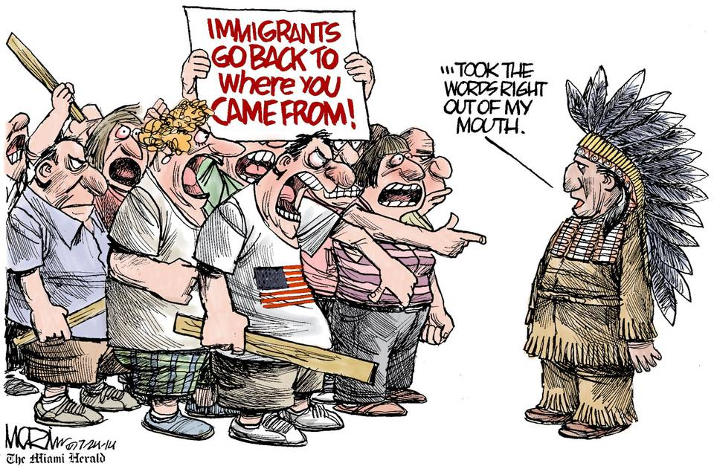
#1
Objects =
People =
Title/Time period =
Inferences =
Conclusions =

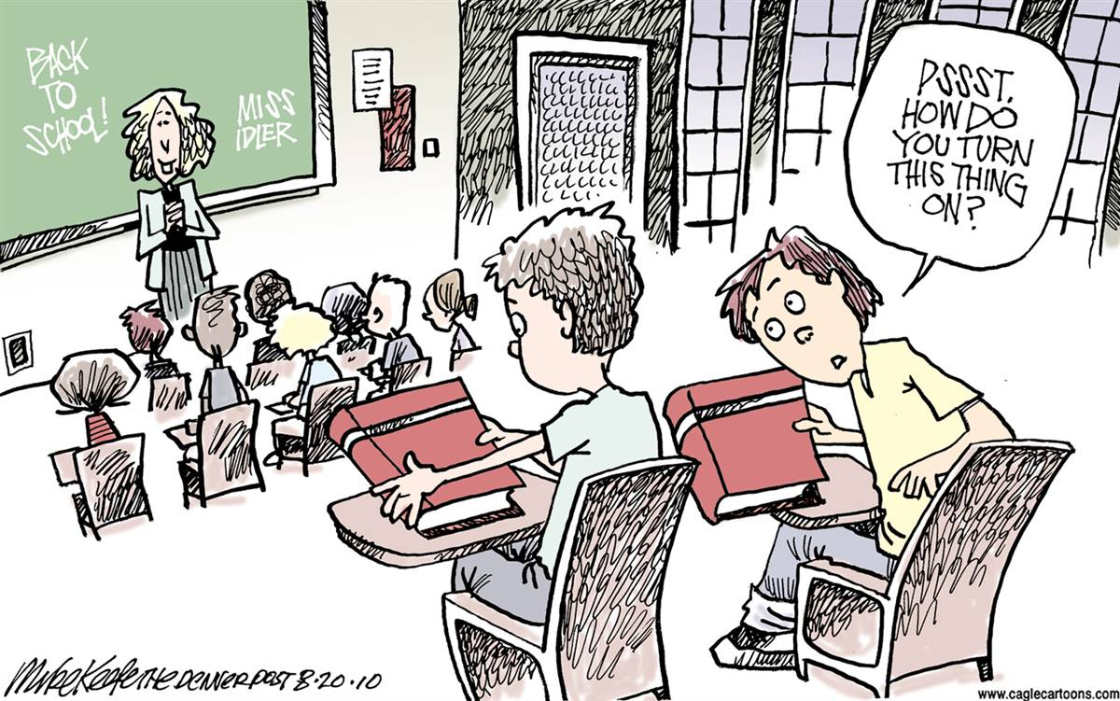
#2

Objects =
People =
Title/Time period =
Inferences =
Conclusions =
Objects =
People =
Title/Time period =
Inferences =
Conclusions =

Summarize =

