North
- Industrial
- City
- No Slavery
- Strong federal government

South
- Agricultural, plantations
- rural
- Slavery
- States’ rights

North

South

The U.S. in 1861
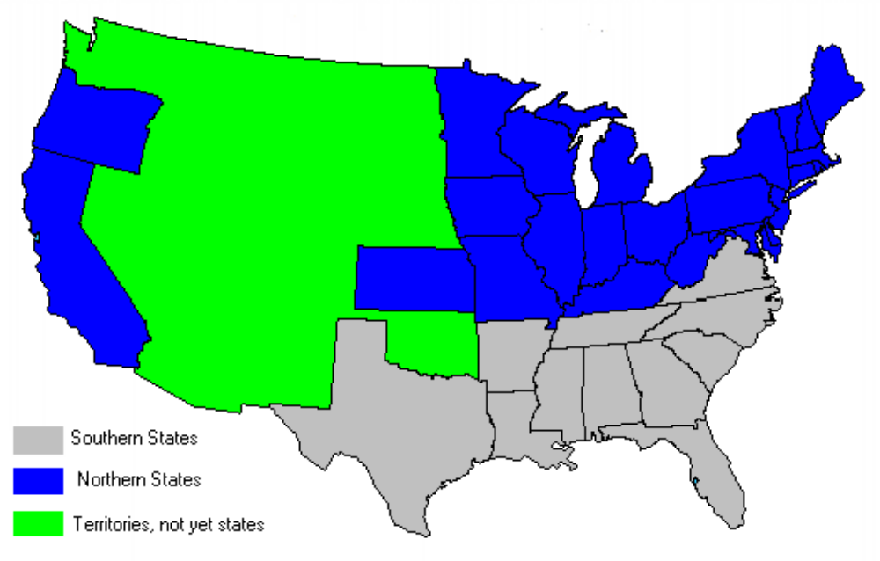
1. Name as many Northern States as you can and as many Southern States as you can.


The North was mostly industrial, meaning it depended on machines and there were many factories, steel mills, railroads.

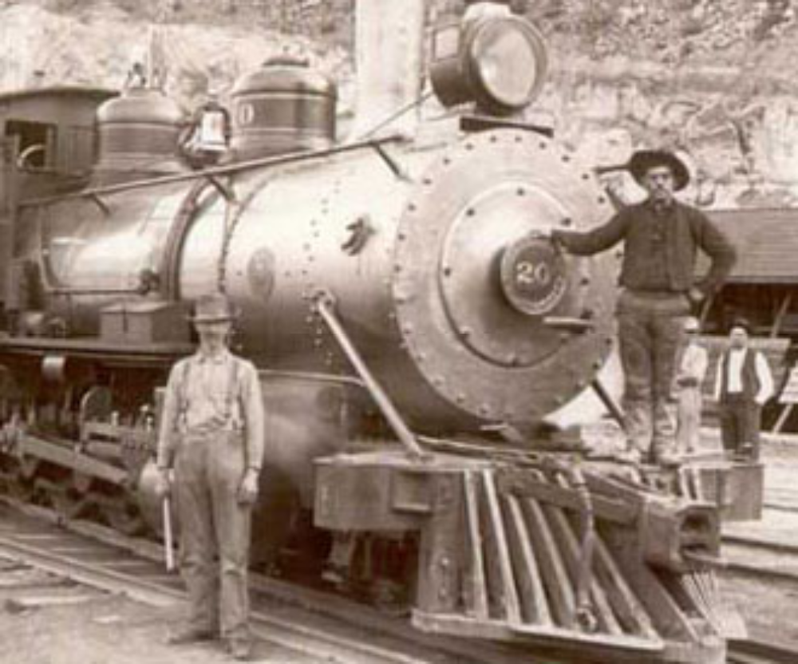

The North was industrial and relied heavily on machines, including railroads.

2. Why did the United States need to build more railroads during the 1800s?
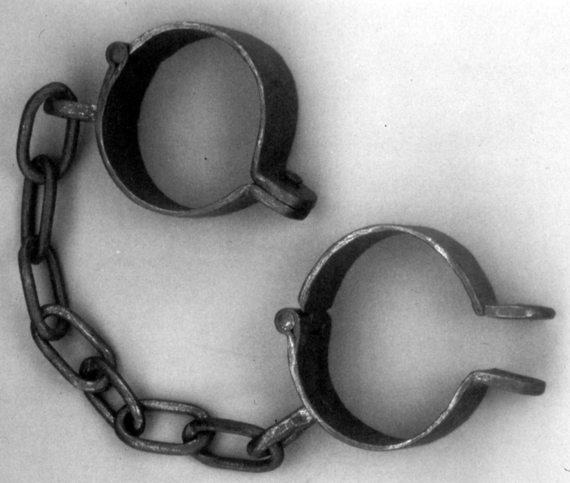

5. What do these chains represent?
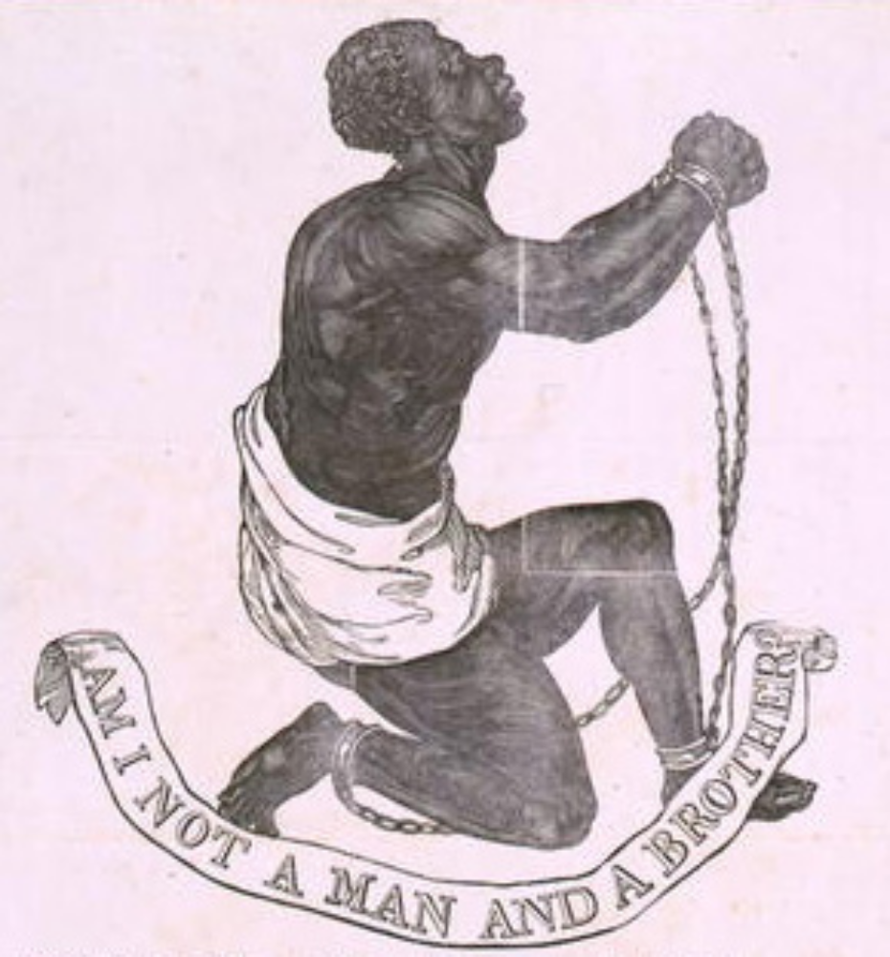

The Southern United States supported slavery because they needed the manpower to work their fields and keep their plantations running.

4. What does the phrase mean, “Am I not a man and a brother?”

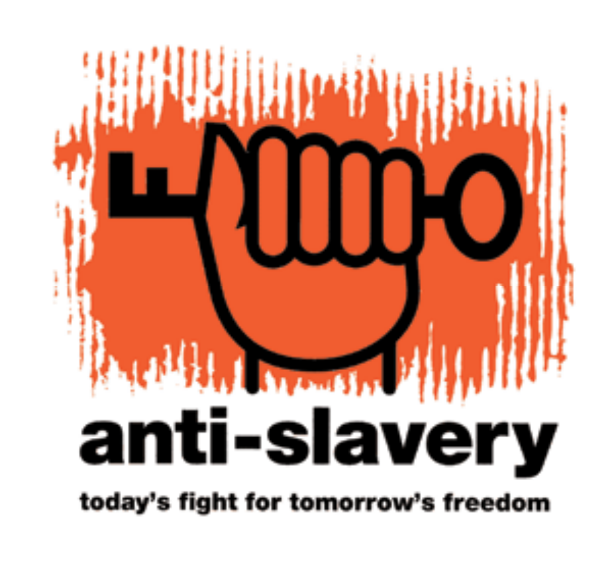

The Northern Untied States opposed slavery because they did not need slaves for their economy (industrial) and felt it was morally wrong.
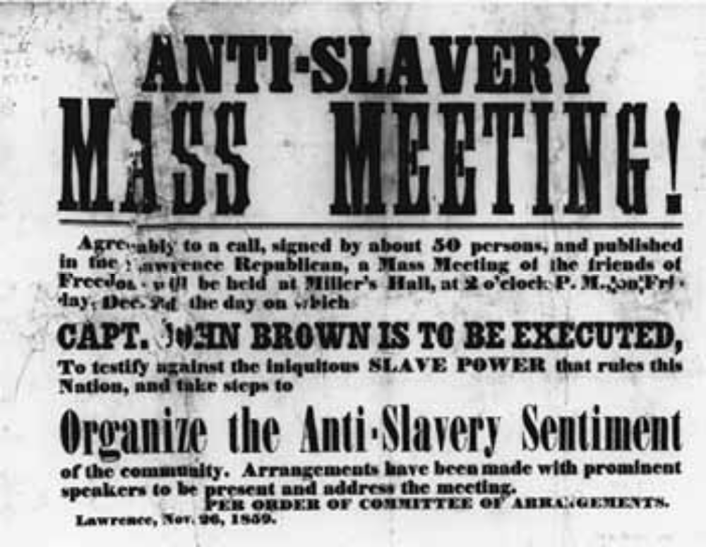

This is a photograph of a newspaper that was printed in the 1860s around the time of the Civil War advertising an anti-slavery meeting.
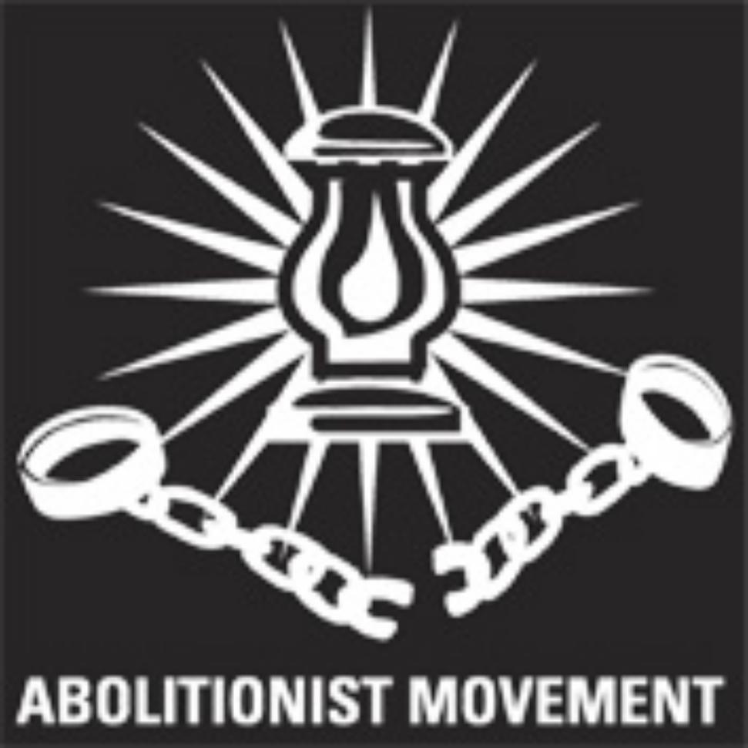

The Abolitionist Movement was rooted in the Northern United States.

3. What do you think abolitionist means based on this picture?
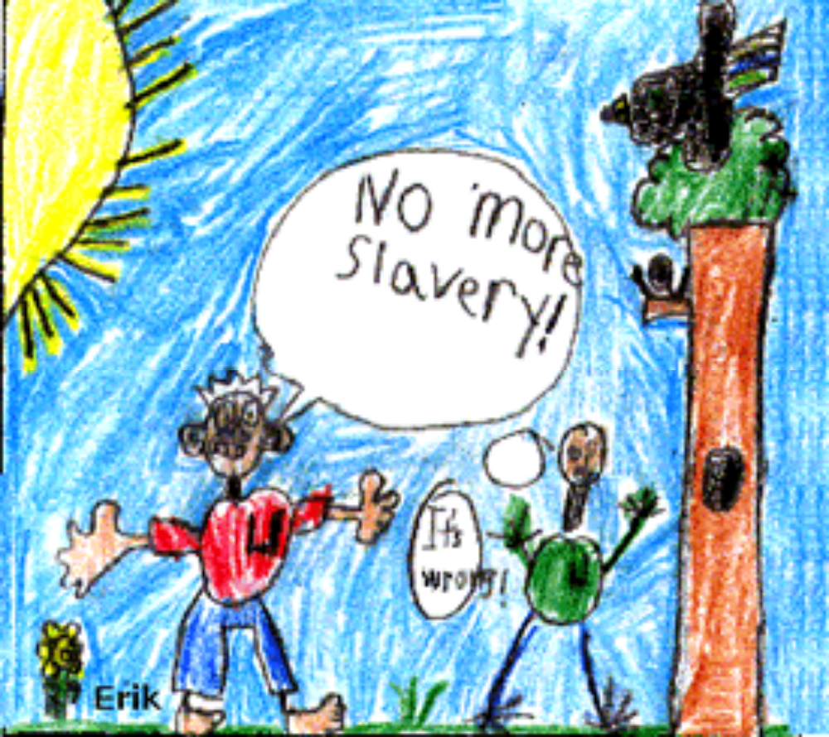

The North did not support slavery. Since it was industrial, the North did not rely on slave labor like the South.
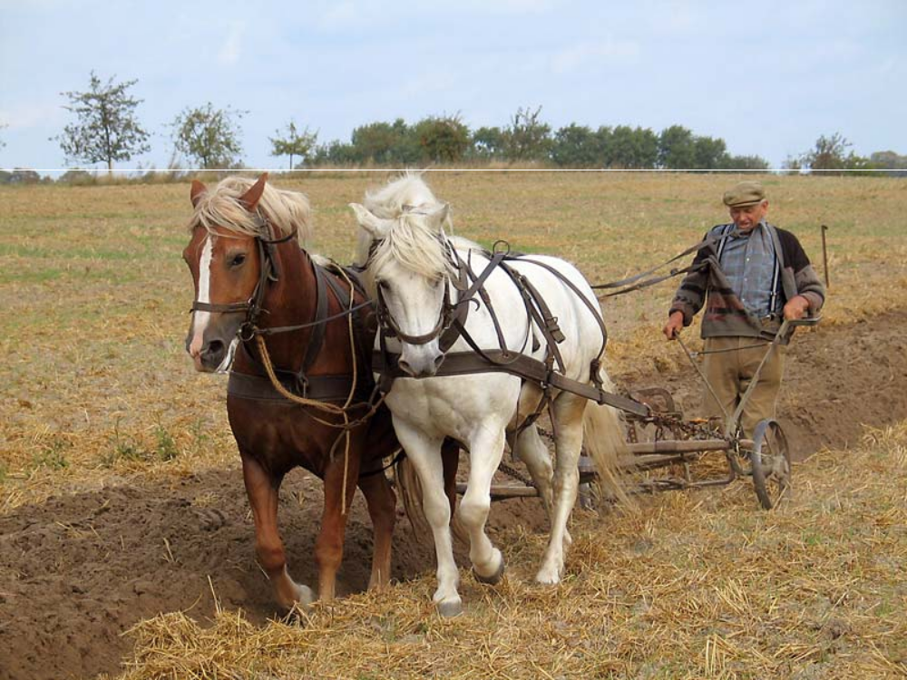

The South was mostly agricultural, meaning there were a lot of farms and plantations (very large farms).

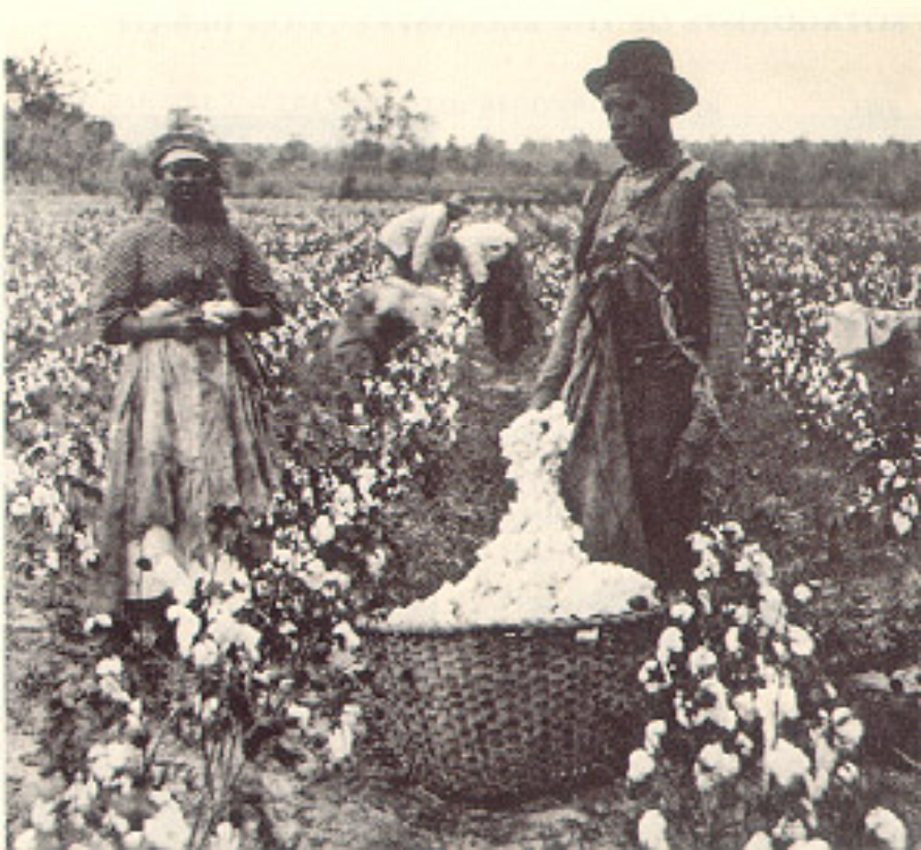

Southerners made money selling the crops they grew on their farms and the cotton they harvested on their plantations. Slaves were used to work the fields and were an important part of their economy (the production, distribution, and selling of goods).

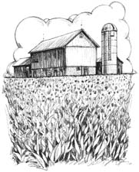

This represents the economy of the South as agricultural and mostly rural (not in the city).

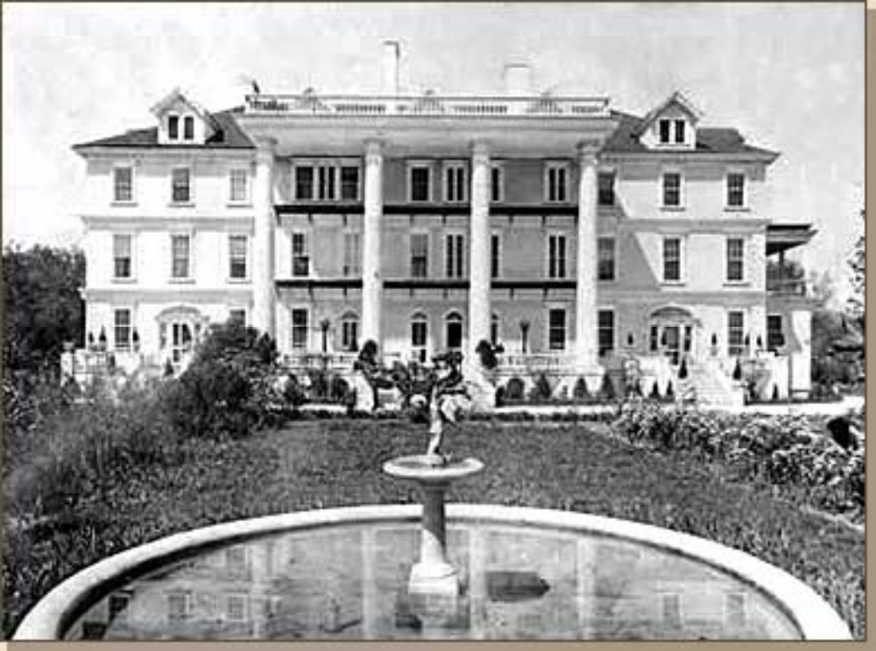

This is a picture of what a plantation in the South would have looked like in the 1850s where slavery was most needed.

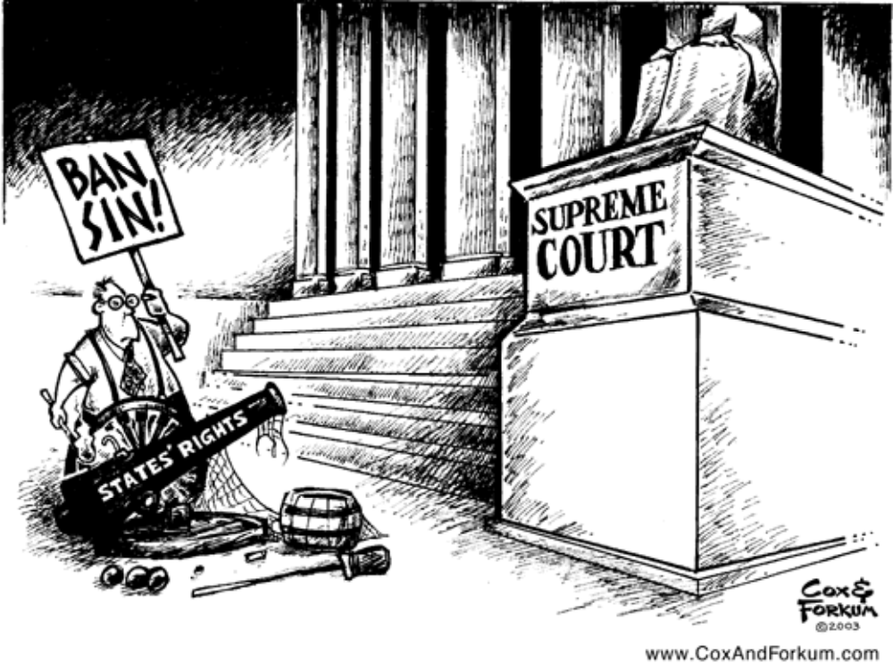

The South believed in states’ rights, meaning they felt that individual states, rather than the federal government, should have the most power. They thought states should be able to determine their own laws.

6. What would happen if the students at Lanier, rather than the principal, had the power to make all the rules?


The North believed in a strong federal government or “big government.” They thought it was crazy to let the states determine their own laws. Instead, everyone should follow the same laws that the federal government makes. Ms. Adams and the administration would be like the federal government at Lanier.

7. What is the danger of “big government?” What happens when power is concentrated in one place?

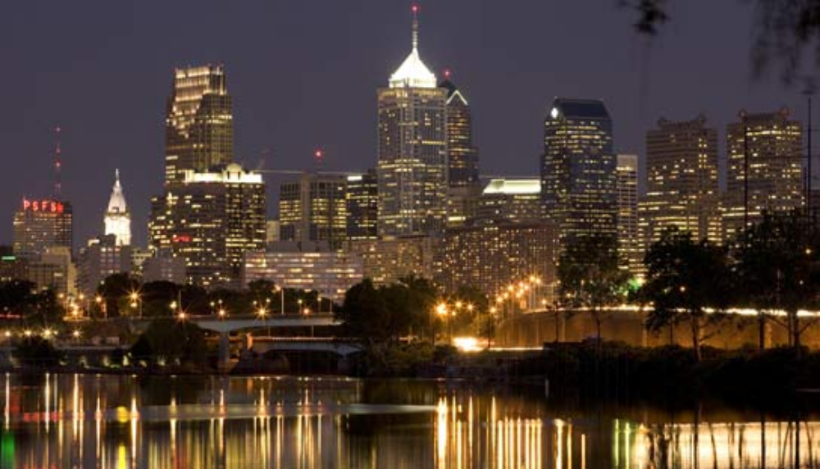

In the North, most people lived in the cities (urban) because that is where most factories and industries were located. In the South, most people lived on farms or plantations in away from the city (rural).

