Name: __________________________________ Class Period: ___________ Brame MYP/Vanguard Texas History Date: _____________________

Native Texan DBQs
Directions: Analyze the following sources and answer the document based questions that follow. Give complete answer with evidence from the documents.

Document #1 – Maps of Texas
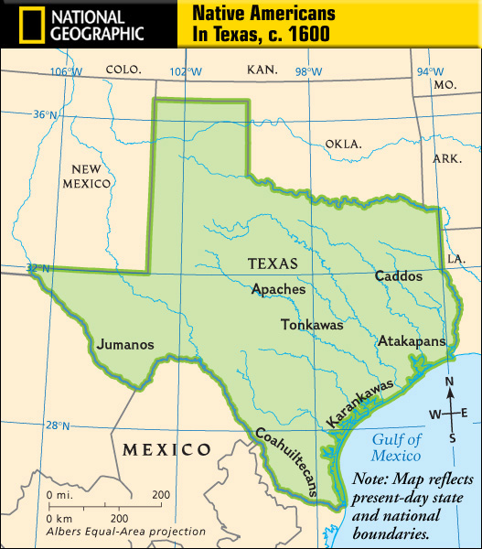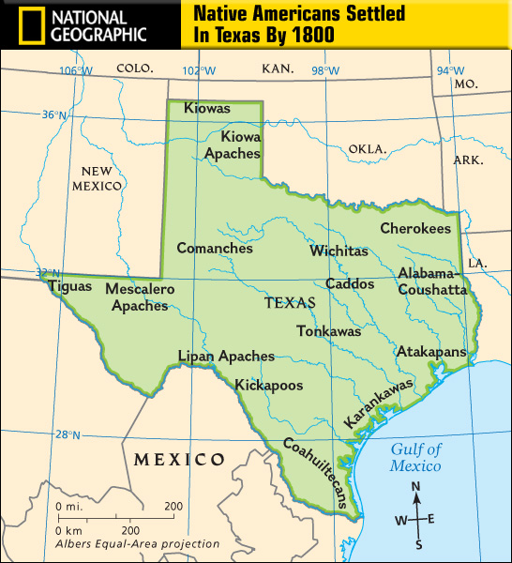
1) Looking at the map of the Natives in Texas in 1600, why do you believe they are located where they are? ___________________________________________
____________________________________________________________________________________________________________________________________________________________________________________________________________________________________________________________________
2) Why do you believe there are more Native tribes in Texas by 1800? _________________________________________________________________________
____________________________________________________________________________________________________________________________________________________________________________________________________________________________________________________________________
3) What physical resources would the Karankawas have relied upon? What about the Jumanos? _____________________________________________________ __________________________________________________________________________________________________________________________________
__________________________________________________________________________________________________________________________________
4) Compare the two maps – some tribes are on both maps and some are not. What reasoned generalizations can you make about the tribes’ movement (or lack of)? __________________________________________________________________________________________________________________________________
__________________________________________________________________________________________________________________________________
__________________________________________________________________________________________________________________________________

Document #2 – Comanche Quote

“Why do you ask us to leave the rivers, and the sun, and the wind, and live in houses? Do not ask us to give up the buffalo for sheep. The young men have heard talk of this and it has made them sad and angry. Do not speak of it no more.
- Comanche Chief Ten Bear

1) Who do you think the chief is addressing in this quote? Why would he feel the need to say it? ___________________________________________
________________________________________________________________________________________________________________________________________________________________________________________________________________________________________________________

2) What culture is the chief from? What changes to their culture does he speak of here? __________________________________________________
________________________________________________________________________________________________________________________________________________________________________________________________________________________________________________________

Document #3 - Cabeza de Vaca Quote
“The people there are tall and well built. Their only weapons are bows and arrows, with which they are very skillful. The men have their lower lip pierced and wear a piece of cane in it half a finger in diameter. Their women do the hard work.”
- Alvar Nunez Cabeza de Vaca

1) What culture could Cabeza de Vaca be describing? Why? ____________
________________________________________________________________________________________________________________________________________________________________________________________________________________________________________________________
2) What is Cabeza de Vaca’s [Spanish explorer] point of view in this quote? How might his POV create bias in his observations? ___________________ ______________________________________________________________
____________________________________________________________________________________________________________________________________________________________________________________________________________________________________________________________________________________________________________________________________________________________________________________

