**Missions Notes**

**Warm-up: If you were at a concert and had to save seats for a few friends, how would you do it?**

**Review: What happens that causes the Spanish to regain interest in Texas (be specific)?**

**Who has claims in North America? How does this affect Texas?**

**Spanish Missions**

**Purpose:**

**1) ______________________________________________________________________________________________________________________**

**2) ______________________________________________________________________________________________________________________**

**First Mission:**

**Corpus Christi de la Ysleta – 1682**



**Most Famous Mission:**

**San Antonio de Valero - 1718 (the Alamo)**

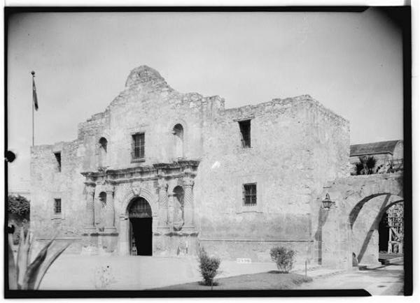

**Why do the Spanish abandon missions?**

**__________________________________________________________________________________________________________________________________________________________________________________________________________________________________________________**

**Spanish Presidios**

**Purpose: _____________________________________________________________________________________________________________**

**Where were they normally located? ____________________________________________________________________________**

**_________________________________________________________________________________________________________________________**

**Spanish Settlements**

**____________________________ becomes the first official settlement in Texas in 1718.**

**Later it becomes the first capital of Texas under Spanish rule.**

**Life in Spanish Texas**

|  |  |  |
| --- | --- | --- |
| **Friars** | **Soldiers** | **Natives** |
| **Convert the Natives** |  | **Learned Spanish and about Catholicism (although most do not convert)** |
|  | **Find Natives that have left the mission** | **Farming, cooking, cleaning, etc.** |
| **Supervise the Natives work (most friars friendly with the Natives, but some took advantage of the free labor)** | **Get supplies to the missions, relied on the El Camino Real** | **Building the missions** |
| **Teach the Natives Spanish** |  | **Learning Spanish crafts** |

**Find these Friars and summarize what they were known for:**

**- Father Damian Massanet (pg. 121) –**

**- Father Francisco Hidalgo (pg. 122) –**

**- Marques de San Miguel de Aguayo (pg. 126) –**

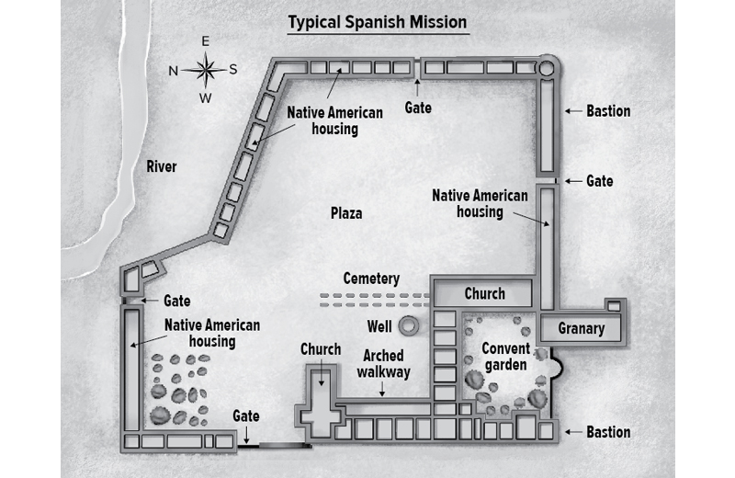

**What observations can you make about the layout of Spanish missions?**

**Spanish Missions in Texas**

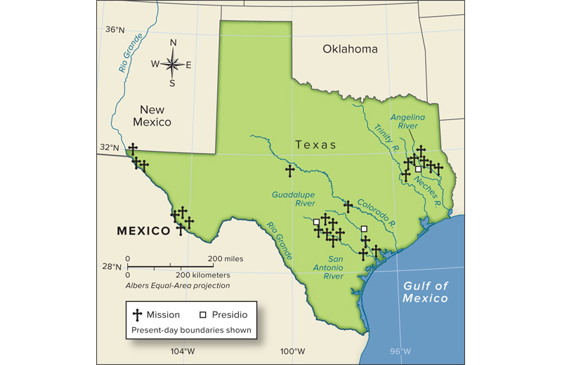

**I. Present day towns & cities: Label in red using the letters following their names. – p. 125**

**El Paso (EP) Nacogdoches (ND)**

**San Antonio (SA) Goliad (G)**

**II. Missions & Settlements: Label the mission and year on map. – p. 125**

**Corpus Christi de la Yselta 1682**

**San Antonio de Valero 1718**

**III. Road: Draw in brown with broken line (- - - - - ):**

**El Camino Real (The Royal Highway) – p. 125**

**Mission Questions**

**1) What was the first Spanish mission built in Texas? When was it built?**

**2) What happened in that year that caused the Spanish to start to settle in Texas?**

**3) San Antonio de Valero is a very famous Spanish mission in San Antonio. What do we call this mission today? What settlement is built around this mission?**

**4) Many Spanish missions were built near *present-day* cities. What is the connection between the missions and present cities?**

**5) Look at the path of El Camino Real. Why did the Spanish build this road?**

# “These Indians are today well instructed and civilized and know how to work very well at their mechanical trades and are proficient in some of the arts. They speak Spanish perfectly, with the exception of those who are daily brought in…They go about well dressed, are abundantly fed.”

**– Father Morfi speaking about Mission San Jose in San Antonio**

**S- ______________________________________________________________________________________________________________________**

**O-______________________________________________________________________________________________________________________**

**A-______________________________________________________________________________________________________________________**

**P-______________________________________________________________________________________________________________________**

**__________________________________________________________________________________________________________________________________________________________________________________________________________________________________________________**

**S-_______________________________________________________________________________________________________________________**

**__________________________________________________________________________________________________________________________________________________________________________________________________________________________________________________**

**“Mission San Saba”**

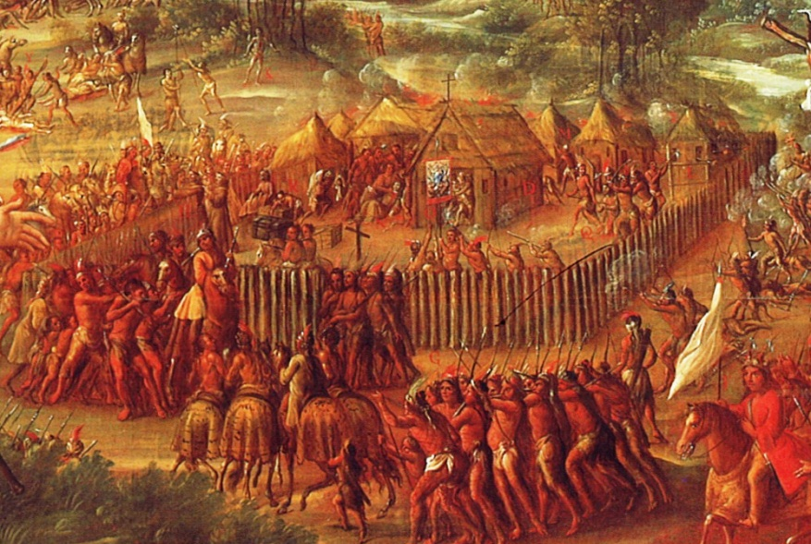

**O-______________________________________________________________________________________________________________________**

**P-______________________________________________________________________________________________________________________**

**T- ______________________________________________________________________________________________________________________**

**I- ______________________________________________________________________________________________________________________**

**__________________________________________________________________________________________________________________________________________________________________________________________________________________________________________________**

**C- ______________________________________________________________________________________________________________________**

**_________________________________________________________________________________________________________________________**

**S-_______________________________________________________________________________________________________________________**

**__________________________________________________________________________________________________________________________________________________________________________________________________________________________________________________**