CLASS SET – DO NOT WRITE ON THIS HANDOUT!
Frontier Life in the West
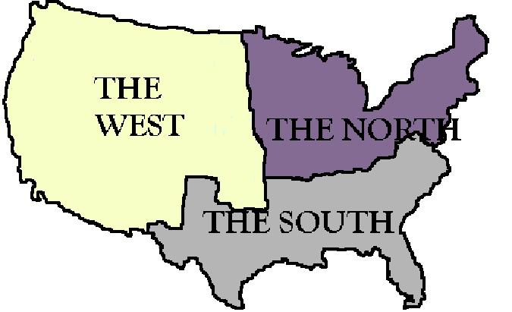
The people who settled the frontier were a varied lot. Most were farmers, skilled and unskilled laborers, miners and prospectors, and, after the Civil War, former soldiers all looking for a better life. Among them were drifters and those with criminal records or a past they wanted to escape. Many were blacks who were attracted to the greater opportunity and freedom from prejudice they hoped to find in the frontier. Many European immigrants came to settle the West, too. Some were miners from England or Wales. Many others, especially Germans, came to the United States after the failed revolutions of 1848. Scandinavians also came in large numbers. And in California, the Chinese came to work as laborers on the transcontinental railroad. The major divisions among all these people were the miners and prospectors, the ranchers and cowboys, and the farmers.
The miners and prospectors went west to find gold. The first great gold rush was in the Far West in 1848 triggered by the discovery of gold at Sutter's Mill in California. In succeeding decades, strikes were made farther inland. From 1856 to 1875 silver was found in southern Arizona, then Colorado and Nevada. Eventually, mining prospered in Idaho, Montana, Washington, and the Black Hills of South Dakota. Mining gave rise to boom towns, some of which eventually became stable and prosperous towns and cities, but many of which became ghost towns when the mines gave out.
The ranchers went west to raise cattle. The open plains were ideal for grazing huge herds, and the completion of the transcontinental railroad in 1869 made it possible to ship the cattle to market in large and profitable numbers. Cattle ranching was a tough business that gave the West its cowboys. Cowboys tended the herds while they were grazing, branded them when they were of age, fought off cattle thieves, and managed the long drives of thousands of cattle over hundreds of miles of open prairie to the railroads. They followed well-known trails, like the Chisholm Trail, that have become a part of the landscape of U.S. folklore. The cattle business made towns like Abilene, KS, and Dodge City, KS. But eventually boom went to bust. The cattle market became glutted, the blizzards of 1886 and 1887 wiped out many ranchers, and competition with farmers for the open range also took its toll.
Farmers had been reluctant, at first, to settle the frontier, and the homesteaders formed the last wave of settlers. At first the land was considered unsuitable for farming. There was little water and there were no trees. On top of that, the Native Americans were hostile. But several developments in the 1870s changed the prospects for homesteaders. Barbed wire was invented, so wood was no longer necessary for poling and fencing. New methods of dry farming were invented and windmills were developed to draw water from underground. Homesteaders moved west. They faced harsh conditions. Their houses were built of sod, blocks of compacted soil cut out of the prairie. They had to deal with hot summers and ice-cold winters, infestations of grasshoppers, prairie fires, and possible confrontations with Native Americans. They also had to contend with ranchers, whose herds and livelihoods were threatened when barbed wire put an end to the open range. Bloody range wars pitted ranchers against farmers and in some cases it was necessary for the U.S. army to intervene. But in the end, the farmers prevailed.
Settling the frontier brought out the best and the worst in people. For miners and ranchers, farmers and cowboys, and the skilled and semi-skilled professionals who helped build and settle the towns, life could be harsh, there were few comforts, and a rough-and-ready democracy prevailed. Men who were poor prospectors one day became fabulously rich the next. Many drank or gambled their money away. Some built prosperous farms and ranches, while others were wiped out. In the early days, there were few women and little of the social stability that comes with family life. Those who settled the West lived by a rough-hewn code made up in part of values they brought with them and values that arose from the lives they lived. Men were prized for their self-reliance, survival skills, and reliability. A man's word was more binding than any written law. The West saw more than its share of violence and bloodshed and tested man's capacity to fight and endure. These values were rooted in the day-to-day living conditions.
Transportation was uncomfortable and often dangerous. Stagecoaches ran over uneven ground and passengers sat on rough wooden benches for long, dusty, cold rides during which they had often to stay alert for Native Americans or bandits. People traveled by wagon trains before the railroads were completed, and they traveled regularly by horseback. Eventually, the railroads expanded, connecting more towns and improving transport, but in the early days even camels were used for transport over the dry prairies. Communication was no less difficult, though the problem was met with characteristic ingenuity and energy. For 19 months, between Apr. 1860 and Oct. 1861, the Pony Express, a relay system of horseback riders, covered the distance between St. Joseph and Sacramento in about 10 days. The system was replaced by the telegraph.
The 3 great threats to the lives of the settlers on the frontier were nature and the elements, Native Americans, and lawbreakers. Everyone was armed and a single lawman was often the only law for 200 or 300 miles around. Desperadoes were not always the colorful or spectacular kind. Most crime had to do with swindles and thefts, the work of claim jumpers, confidence men, card sharps, and rustlers. If caught, these men often faced rough justice, if not at the hands of an individual, then at the hands of vigilantes or a lynch mob. But the Old West had a deep ambivalence about the law. It admired tough and independent characters, gamblers who took chances and won, people who knew how to fight for and keep what was theirs. It admired a tough lawman but was suspicious of government.
Finally, there were the Native Americans. After people continued to settle the frontier, there was finally no room for buffalo or tribes of nomadic hunters. The Native Americans occupied the land of the last frontier, presumably protected by treaties, but the treaties gave way to the overwhelming drive for riches, land, and the territorial ambitions of a growing nation-state. The Native Americans resisted and the settlers and the government fought back. The U.S. Army established forts and outposts to protect settlers and subdue the Native Americans. In the process, both fear and greed combined to weave into the ethos of the West the conviction that the only good Indian was a dead Indian. The result was the systematic reduction, the demoralization and decimation, of the Native American peoples, in open warfare or in massacres, like the one near Sand Creek, CO in 1864. Nonetheless, the Native Americans left a mixed legacy among the people who settled the frontier. There were many who admired their courage and skills and there were those, among them agents of the Indian Bureau, who attempted to mitigate their destruction.

