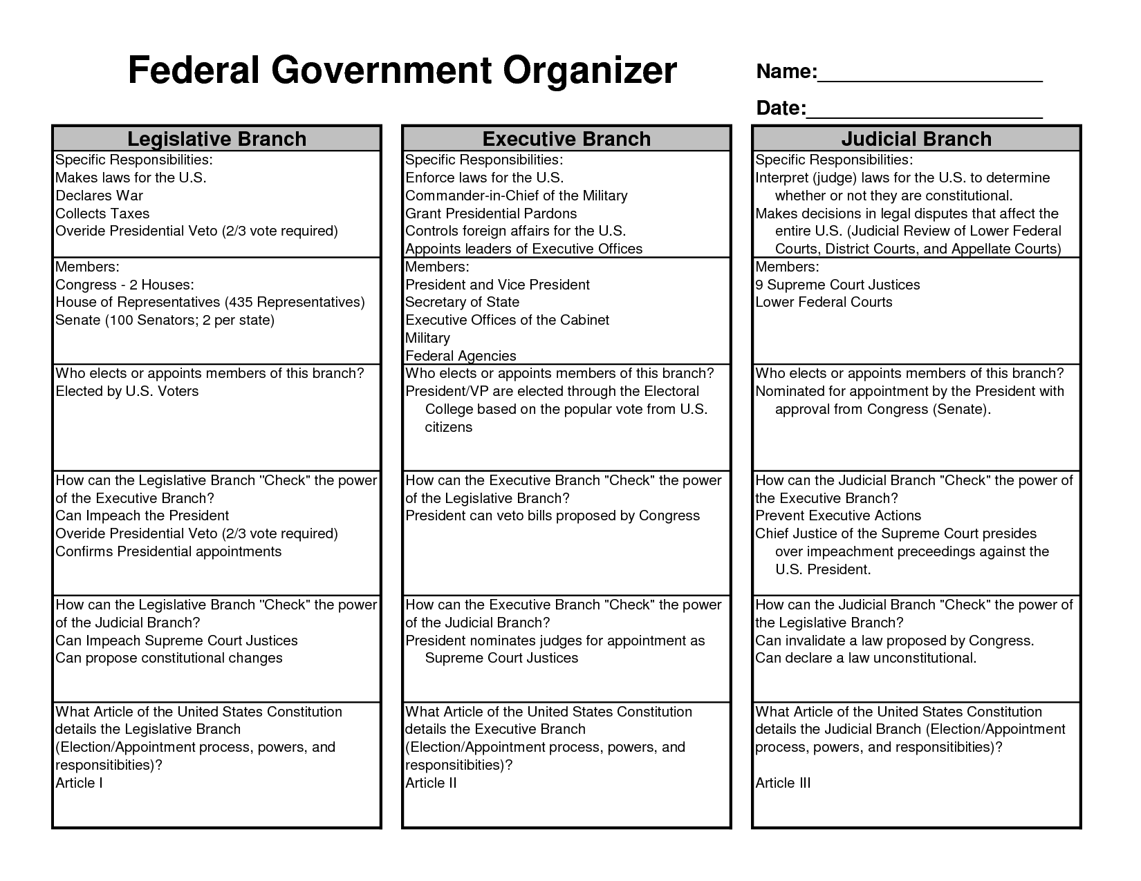

Name: _______________________________________ MYP TX History Class Period: ____
U.S. Government
Directions: Use the information from the Federal Government Organizer on the 3 branches of government to create a visual representation of the following government concepts on the tree provided.
Constitution: Creates the organization and guidelines for our government. The Constitution should be the roots/trunk of your tree to represent that it supports the 3 branches.
Separation of Powers: Is the division of powers (jobs) between the three branches to make sure that no one branch has too much power. Using the three branches on the tree first, write the names of the three different branches. Second, write who works in that branch at the federal level. Third, write the actual power of the branch (what do they do?).

