Name: _________________________ Class Period: _______

Brame MYP/Vanguard Texas History Date: ____________

**The First Texans**

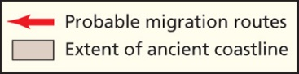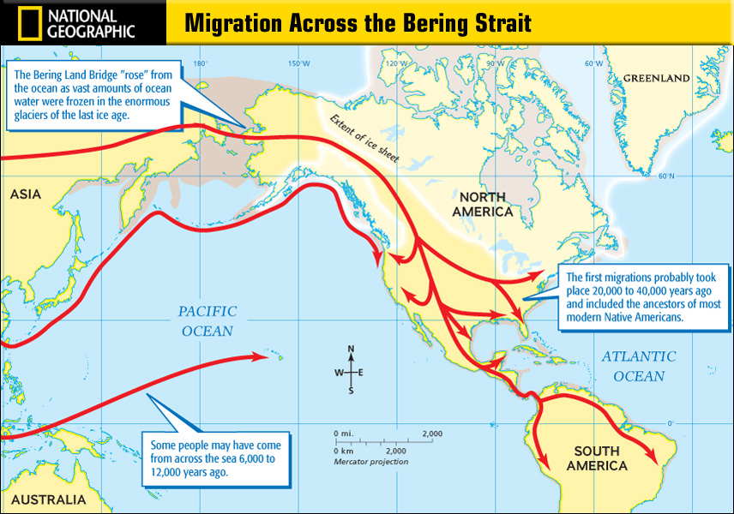

Why did they come to Texas?

__________________________________________________________________________________

What were they following?

__________________________________________________________________________________

What HUGE event in history caused this migration?  
__________________________________________________________________________________

|  |  |  |
| --- | --- | --- |
| **The Stone Age** | | |
| The earliest people… | Then they began to… | And finally… |
|  |  |  |

***The first humans reached Texas about 10,000 years ago!***

**Large mammals become extinct, and the First Texans are forced to adapt…**

What would they find in the different areas of Texas? _______________________________________  
____________________________________________________________________________

What do they need to do to survive? ___________________________________________________  
____________________________________________________________________________

How would they adapt and modify the environment? _______________________________________  
____________________________________________________________________________

What technology would they have needed? ______________________________________________  
____________________________________________________________________________

**The Four Native Texan Cultures**

|  |  |  |  |
| --- | --- | --- | --- |
| Plains | Pueblo | Southeastern | Gulf |
|  |  |  |  |
| Geographic Region(s): | Geographic Region(s): | Geographic Region(s): | Geographic Region(s): |
| Tribes: | Tribes: | Tribes: | Tribes: |

