Name:__________________________ Date:_____________
Brame MYP/Vanguard Texas History Class Period: ______

Texas Empresarios: Cheap land, come and take it!
Stephen F. Austin
Where was my colony located?

What group of immigrants settled in my colony?

What is my contribution to Texas history?
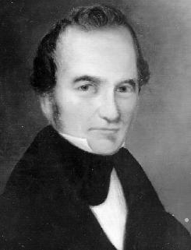

Erasmo Seguín
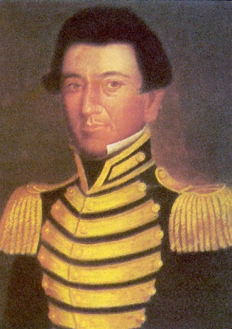
What were my jobs?

What was my role during the Anglo settlement of Texas?

What is my contribution to Texas history?

Green DeWitt
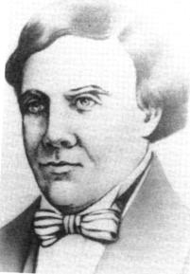
Where was my colony located?

What problems did I have in my colony?

What is my contribution to Texas history?

Martín De León
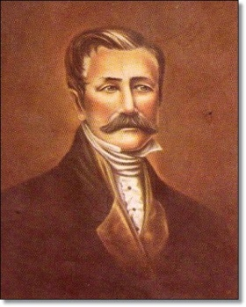
Where was my colony located?

What group of immigrants settled in my colony?

What is my contribution to Texas history?

Benjamin Milam
Where was my colony located?

What problems did I have in my colony?

What is my contribution to Texas history?

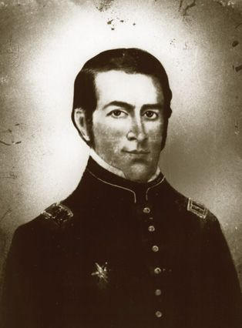

Lorenzo de Zavala
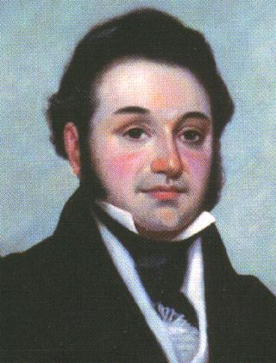
Where was my colony located?

What happened to my land grants?

What is my contribution to Texas history?

Haden Edwards
Where was my colony located?

What problems did I have in my colony?

What is my contribution to Texas history?

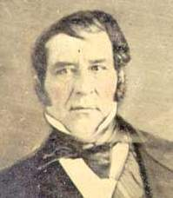
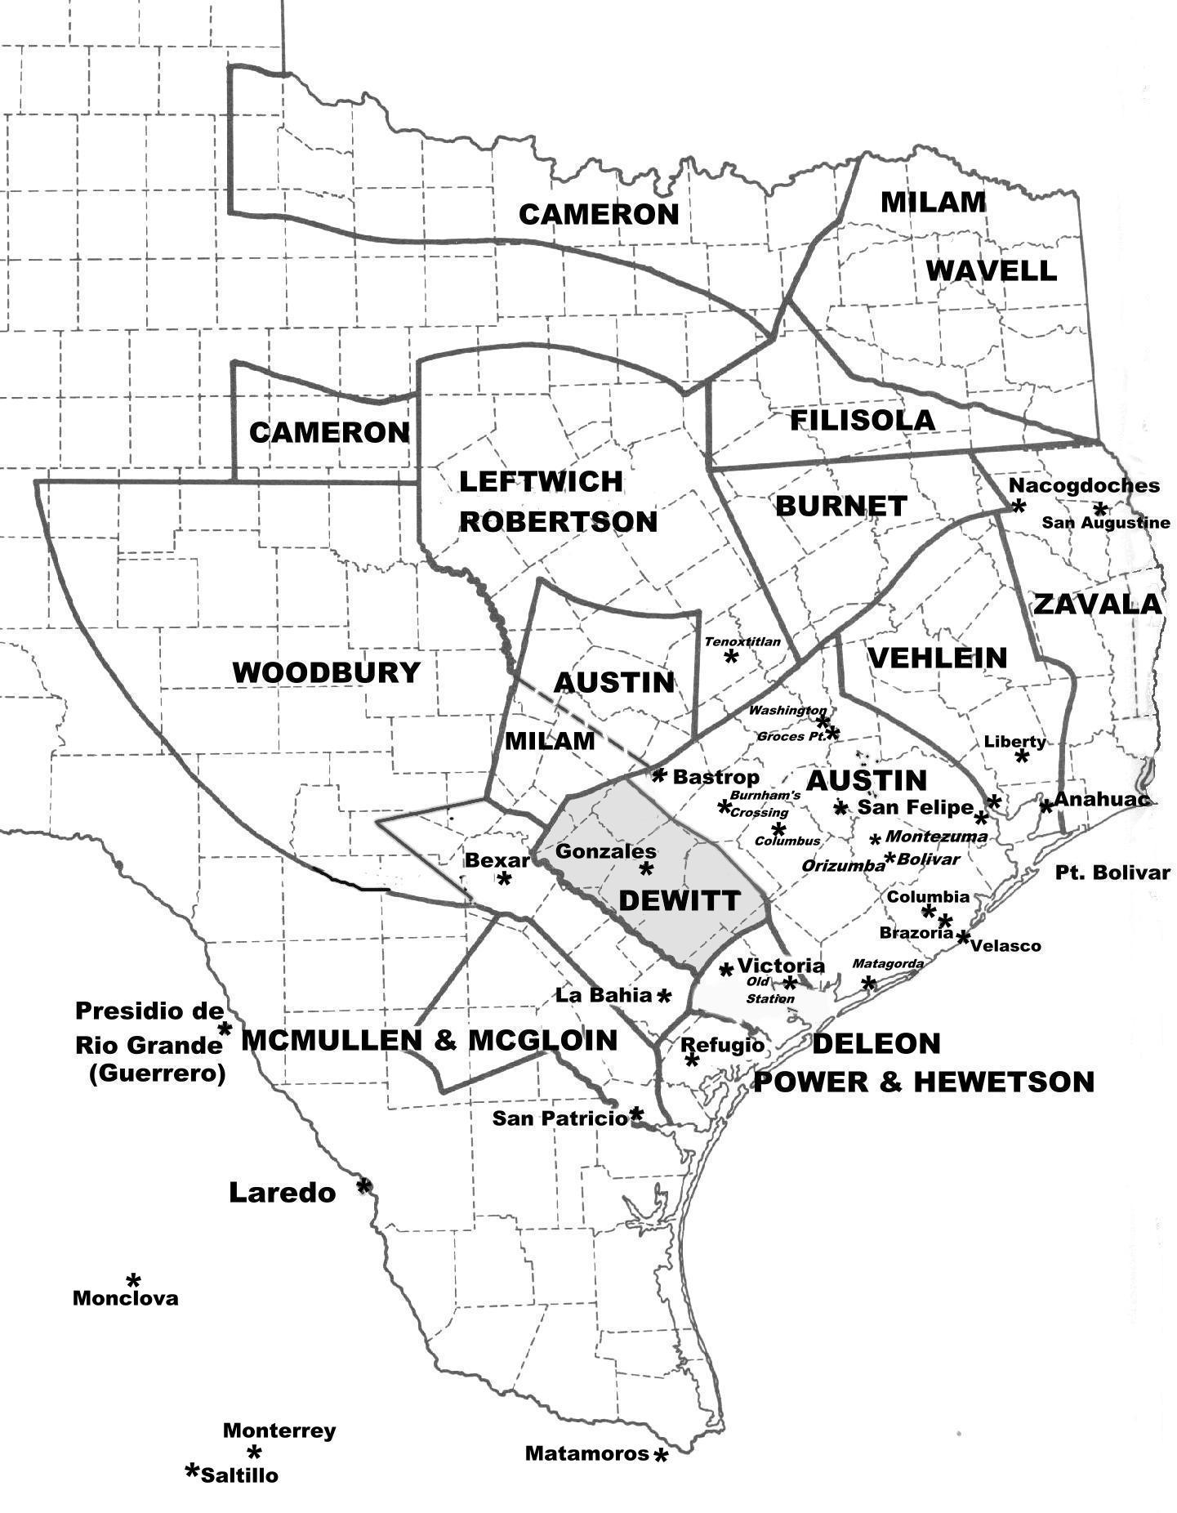

- Create a title, compass rose, and key for the map above. Color code the colonies of Austin, DeWitt, De León, Milam, and Zavala to make your key. For example, DeWitt’s colony is gray.

- Which colony was the most populated/developed? How can you tell?

- In general, which regions of Texas were most colonies located in? Why?

- In general, which regions of Texas were colonies NOT located in? Why?

- Based on the map and your prior knowledge, who do you think was the most successful empresario? Why?

- Create a title, compass rose, and key for the map above. Color code the colonies of Austin, DeWitt, De León, Milam, and Zavala to make your key. For example, DeWitt’s colony is gray.

- Which colony was the most populated/developed? How can you tell?

- In general, which regions of Texas were most colonies located in? Why?

- In general, which regions of Texas were colonies NOT located in? Why?

- Based on the map and your prior knowledge, who do you think was the most successful empresario? Why?

Stephen F. Austin
Stephen Fuller Austin, founder of the first Anglo-American colony in Texas, was the son of Moses Austin. He grew up in Virginia/Missouri and worked as an attorney until his father, Moses Austin, decided that Texas needed to be explored and settled for American citizens. Though not enthusiastic about the Texas venture, Austin decided to cooperate with his father, but Moses died before his dream could be realized. Authorized by Governor of Tejas to carry on the colonization enterprise under his father's grant, Austin came to an understanding about certain administrative procedures and was permitted by the governor to explore the coastal plain between the San Antonio and Brazos rivers for the purpose of selecting a site for the proposed colony. He settled 300 Anglos in Austin Colony and was very successful in his future settlement, bringing as many as a 1000 or more Anglos to Texas. He became known as the “Father of Texas” and had a strong relationship with the Tejanos and Mexican Government.

Haden Edwards
Haden (or Hayden) Edwards, was the son of John Edwards (a Kentucky Senator). Haden was educated for the law but like his father was more interested in land speculation. Edwards first heard the news of Moses Austin's plans for colonization in Texas in 1823. He traveled to Mexico City, where he helped Stephen F. Austin and others get permission to settle Anglos. Haden received a grant in the vicinity of Nacogdoches where he could locate 800 families. Like other empresarios he agreed to honor preexisting grants and claims made by Spanish or Mexican officials. From the beginning Edwards had issues with the Mexican government and people claiming land on his grant. This eventually led to the Fredonian Rebellion, which was quickly suppressed by the Mexican officials in the area. Edwards was arrested but still managed to create the Fredonian Republic once he was freed. Before an armed clash occurred, the Fredonians dispersed in early February 1827, and Edwards fled to Louisiana for safety. He returned to Texas during the Texas Revolution and made his home in Nacogdoches until his death, on August 14, 1849.

Lorenzo De Zavala
Manuel Lorenzo Justiniano de Zavala y Sáenz, was born near the Yucatán, on October 3, 1788. Early in his life he was known for his support of democratic reforms, which led to his imprisonment in 1814 in the fortress of San Juan de Ulloa in the harbor of Veracruz. There he gained enough knowledge from reading to teach himself to read English. From 1821 to his death he served various roles in the Mexican government and later becomes the Vice President of the Republic of Texas. In 1829, Zavala earned grants for his work, which authorized him to settle 500 families in a huge tract of land in what is now southeastern Texas. In an effort to sell his grants to eastern investors, he visited New York City. He ended up transferring his grants to the Galveston Bay and Texas Land Company. He goes down in Texas History for his contribution in the drafting of the constitution of the Republic of Texas. Unfortunately, toward the end of his life, he had disagreements with the new Republic of Texas Government and resigned as Vice President. Shortly thereafter, Zavala returned to his home in poor health and developed pneumonia from a boat accident, to which he succumbed on November 15, 1836.

Benjamin Milam
Benjamin Milam, was born in Frankfort, Kentucky, on October 20, 1788. When he was of age, he enlisted in the Kentucky militia and fought for several months in the War of 1812. His fighting spirit caused him to join the effort for Mexican Independence. He was granted Mexican citizenship and commissioned a colonel in the Mexican army in 1824. He also obtained empresario grants in northeast Texas. He did have trouble fulfilling his required number of settlers specified in his empresario contracts because of new Mexican immigration laws. The growing unrest in 1835 caused Milam to once again join a new army that was fighting for Texas Independence. Unfortunately, Milam did not survive to witness the victory; on December 7 he was shot in the head by a sniper and died instantly.

Martín De León
Martín De León, the only Mexican empresario to found a colony in Texas, was born in 1765 in Burgos, Nuevo Santander. The De Leóns were an aristocratic family of great wealth and were acquainted with European rulers. Martín, however, declined his father's offer to complete his education in Monterrey and Europe and instead settled in central Texas. He had large numbers of cattle and became one of the earliest trail drivers in Texas. On April 8, 1824, De León petitioned the provincial delegation at San Fernando de Béxar to settle forty-one Mexican families on the lower Guadalupe and founded the town of Nuestra Señora Guadalupe de Jesús Victoria. The colonization grant was approved. De León's colony was the only predominantly Mexican colony in Texas, and as a Mexican citizen, the empresario received legal preference in the numerous border disputes with American settlements encircling Guadalupe Victoria. As a devout Catholic, De León was planning to build a church without rival in Texas when he became a victim of the cholera epidemic of 1833 and died, leaving his widow, four sons, and six daughters an estate of over a half million dollars.

Erasmo Seguín
Erasmo Seguín, San Antonio political figure, postmaster, and businessman, was born in San Antonio on May 26, 1782. Erasmo Seguín's public career began in 1807 when he became San Antonio postmaster, a position he held until October 1835 with only two interruptions. In 1821 Governor Antonio Martínez appointed him to inform Moses Austin that the latter's petition to start a colony in Texas had been approved. Seguín's most important commission, however, was his service as Texas representative to the congress that wrote the Constitution of 1824. Seguín worked in Mexico City to promote the interests of both his native San Antonio and the Anglo-American settlers. As a member of the colonization committee, he worked on the liberal National Colonization Law of August 18, 1824. Seguín also developed business and personal ties to Stephen F. Austin, who often stayed with the Seguíns during his travels through the area. During the 1840s and 1850s Erasmo Seguín dedicated himself to his ranch, where he died on October 30, 1857.
Green DeWitt
Green DeWitt was born on February 12, 1787, in Lincoln County, Kentucky. DeWitt enlisted in the Missouri state militia in the War of 1812 and achieved the rank of captain by the war's end. In 1821 he was inspired by Moses Austin's widely circulated success in obtaining a grant from the Spanish government to establish a colony in Texas. Aided by Austin, he was awarded an empresario grant on April 15, 1825, to settle 400 Anglo-Americans on the Guadalupe River. He eventually settled at Gonzales, with his wife and kids (his wife created the “Come and Take it” Flag). DeWitt apparently did not have the degree of personal influence over his settlement that Austin exercised at San Felipe and struggled to get enough settlers. For the most part, his colony proved neither materially nor financially rewarding for him. The Mexican government ended up removing Anglos from DeWitt’s colony because he did not fulfill his required empresario grant. While trying to get another land grant in Coahuila, DeWitt contracted a fatal illness, probably cholera. He died on May 18, 1835, and was buried there in an unmarked grave.

