Name: ____________________________________ Date: ________________
Brame MYP/Vanguard Texas History Class Period: _______

Compromise of 1850

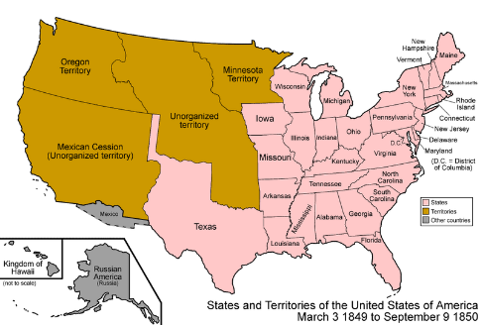
Henry ____________’s solution to help maintain the balance of power between free states and slave states in Congress while avoiding further conflict…

- Texas agreed to surrender its claims to some _________________________ areas (New Mexico and part of Texas’s northern territory)
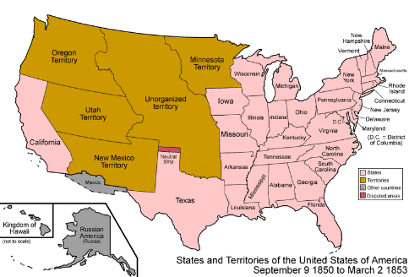
- The US agreed to give Texas $ ________ million in return
- California was admitted to the U.S. as a ____________________ state
- _________________________________ could vote on the issue of slavery
- Stronger Fugitive Slave Act and ban on __________________________ in Washington D.C.

Name: ____________________________________ Date: ________________
Brame MYP/Vanguard Texas History Class Period: _______

Compromise of 1850

Henry ____________’s solution to help maintain the balance of power between free states and slave states in Congress while avoiding further conflict…

- Texas agreed to surrender its claims to some _________________________ areas (New Mexico and part of Texas’s northern territory)
- The US agreed to give Texas $ ________ million in return
- California was admitted to the U.S. as a ____________________ state
- _________________________________ could vote on the issue of slavery
- Stronger Fugitive Slave Act and ban on __________________________ in Washington D.C.

