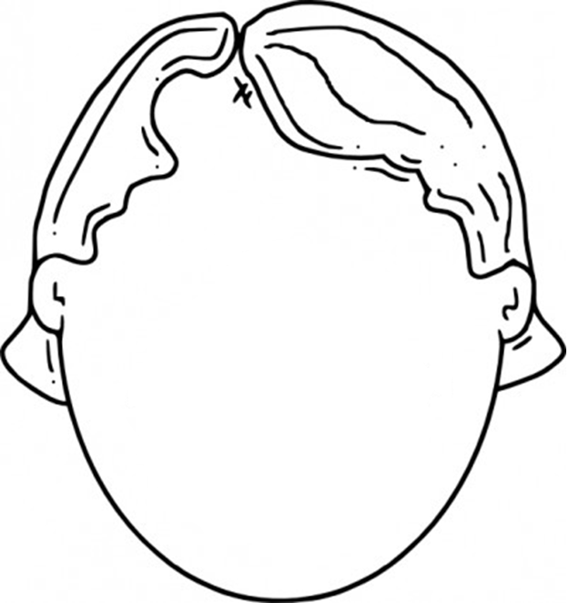

**Columbus and I are both** _________________________________ **because** _____________________________________________________________  
__________________________________________________________________________________________________________________________**.**

**OR**

Name: ______________________________________ Date: ____________________ Period: _______

**BAD GUY**

* ________________________________________________________________________________________________________________________
* ________________________________________________________________________________________________________________________
* ________________________________________________________________________________________________________________________
* ________________________________________________________________________________________________________________________
* ________________________________________________________________________________________________________________________

**GOOD GUY**

* ________________________________________________________________________________________________________________________
* ________________________________________________________________________________________________________________________
* ________________________________________________________________________________________________________________________
* ________________________________________________________________________________________________________________________
* ________________________________________________________________________________________________________________________