COLUMBIAN EXCHANGE
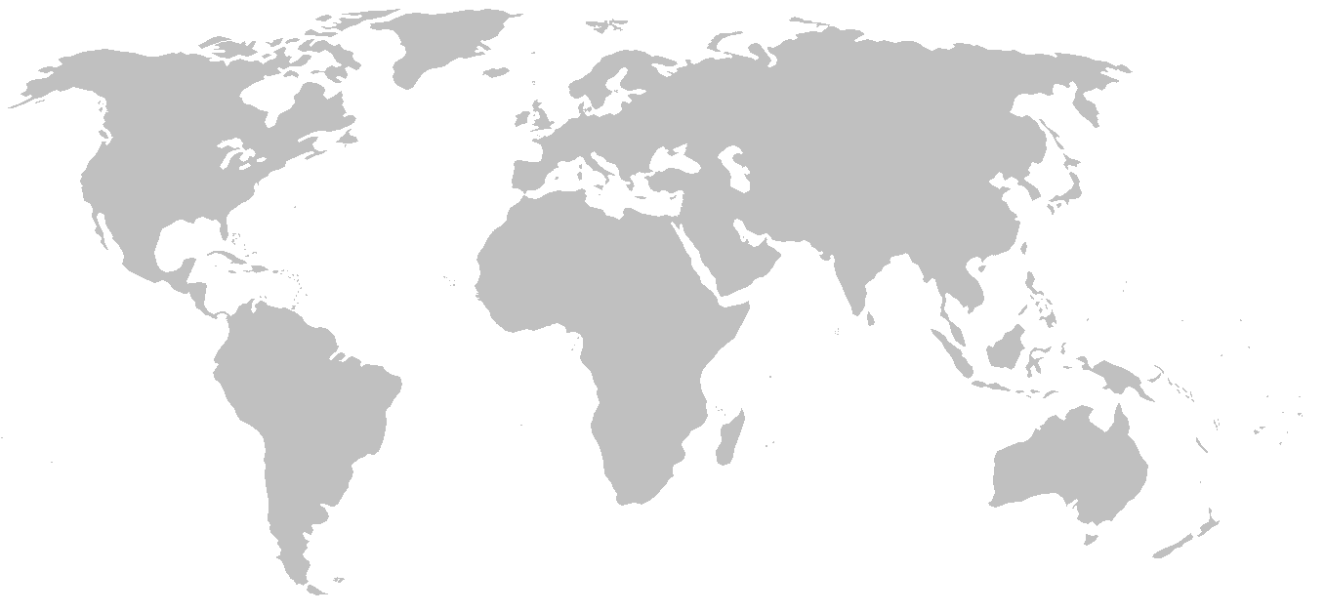
NEW WORLD: THE AMERICAS OLD WORLD: EUROPE, ASIA, AND AFRICA
Plants/Crops
Animals
Plants/Crops
Ideas/Technology
Disease
Animals

- Was the Columbian Exchange a positive event in history? Why or why not?

- How do you think the Columbian Exchange affected the Native Americans? Give one positive and one negative prediction.

- What do you think happened to the balance of power in the world following the Columbian Exchange?

- How does the Columbian Exchange affect your life today?

