Name: __________________________________ Date:_____________
Brame Vanguard/MYP Texas History Class Period:________

EXTRA CREDIT is optional; this is simply an opportunity to raise your average. This assignment will replace your lowest single or double grade.

Civil War Movie Analysis
DUE DATE: May 16th, 2014

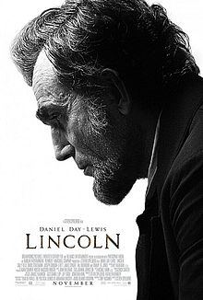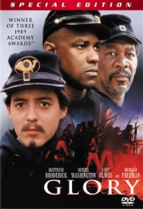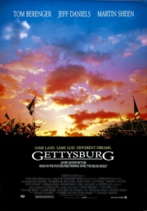

Task: Watch your chosen movie that depicts events during the U.S. Civil War. You will type a half page synopsis (summary) of the movie and you will give the movie a half a page review based on the following guidelines (total of one page typed, double-spaced).
1) How historically accurate is the movie (you might need to do some outside research)?
2) Do the actors make you feel and understand the hardships of war?
3) Are the main conflicts of the Civil War portrayed within the film?
4) Did you like the film?

Format: Typed 12 point Time New Roman font, double spaced. Title is name of the film. The review should be written as if it will be used for an online blog (you can be less formal in your tone). The two assignments will be on the same sheet or they can be stapled together.
Movie Choices
*If you have another movie on the Civil War, just run it by me first.

Glory (1989) – Story of the 54th Massachusetts Volunteer Army
Actors - Denzel Washington, Morgan Freeman, and Matthew Broderick

Lincoln (2012) – Story of Lincoln’s fight for the 13th amendment
Actors – Daniel Day-Lewis, Sally Fields, and Tommy Lee Jones

Gettysburg (1993) – Story of the Battle of Gettysburg
Actors- Jeff Daniels, Tom Berenger, and Martin Sheen

****All films contain violence and mature themes****

