Civil War Battle Map

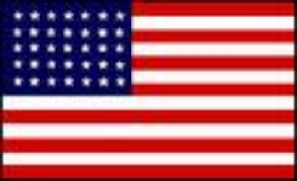 VS. 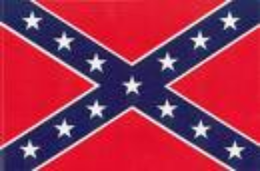

Directions: Using information from Chapter 16 in the American Republic textbook, complete the map while paying close attention to the guide that follows:

Part One: Lightly shade the following states on your map. (Use pages 470, 487, and 489)
- Union = blue
- Border States (Missouri, Kentucky, Maryland, Delaware, and draw in West Virginia) = green
- Confederacy = gray

Part Two: Label the following bodies of water.
- Mississippi River 3. Atlantic Ocean
- Ohio River 4. Gulf of Mexico

Part Three: Put a dot on the map for the following battles and label them.
- Fort Sumter, South Carolina (p. 470) 4. Gettysburg, Pennsylvania (p. 487)
- Antietam, Maryland (p. 470) 5. Appomattox, Virginia (p. 489)
- Vicksburg, Mississippi (p. 487)

Part Four: Read about the Civil War’s key events below, and complete the directions that follow.
.
The Civil War formally began with the attack on Fort Sumter. The first shots were fired on April 12, 1861 by the Confederacy. No one died from the battle, but the Union surrendered. The Confederacy had won the first battle of the Civil War.

Directions:
- Put a #1 by Fort Sumter, S.C.
- Write “C” next to it to represent the Confederate victory.

The Anaconda Plan was the battle strategy used by the Union during the Civil War. It was proposed by General Scott in 1861. The goal of the Anaconda Plan was two-fold:
1. Blockade the coast of the South to prevent the export of cotton, tobacco, and other cash crops from the South and to keep them from importing much-needed war supplies.

2. Divide the South by controlling the Mississippi River to cut off the southeastern states from the West.

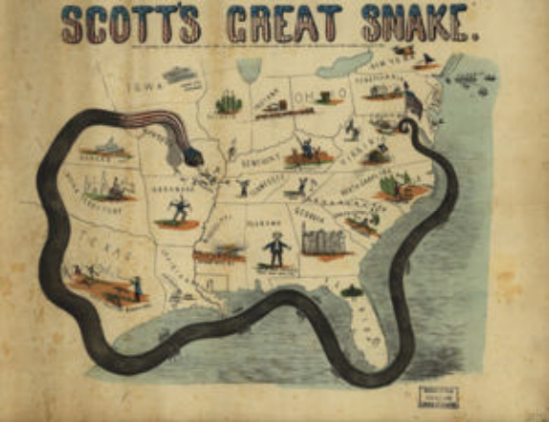

Directions:
- Draw a thick line like the one in the picture above representing the North’s Anaconda Plan (see above).
- Draw a key on your map to show what this line represents.
The Battle of Antietam was the bloodiest single day battle in the Civil War. Union troops led by General George B. McClellan and Confederate troops led by General Robert E. Lee clashed on September 17, 1862. At the end of the day, about 23,000 soldiers were dead. The Confederates retreated and the Union claimed victory.

Directions:
- Draw 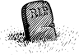by Antietam to represent the number of lives lost.
- Write “U” for the Union victory.

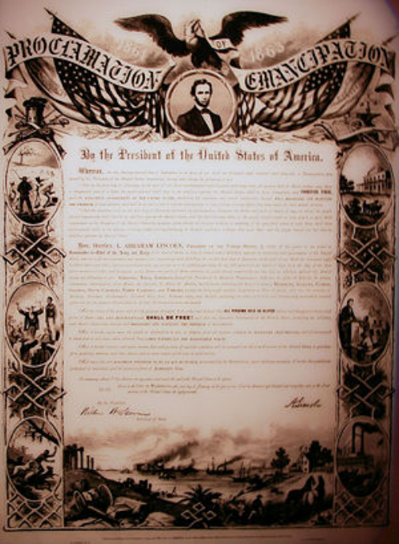
From the start of the war through the brutal Battle of Antietam, the Northerners’ main goal was to preserve the Union rather than to destroy slavery. Lincoln considered slavery immoral but hesitated to ban slavery all together. Lincoln’s indifference was obvious when he said, “If I could save the Union without freeing any slave, I would do it; and if I could save it by freeing all the slaves, I would do it; and if I could save it by freeing some and leaving others alone, I would also do that.” On January 1, 1863, Lincoln signed the Emancipation Proclamation, an order to free all slaves in the Confederacy. The Emancipation Proclamation read, “…all persons held as slaves within any state…in rebellion against the United States, shall be then, thenceforward, and forever free.” By signing the Emancipation Proclamation, Lincoln weakened the South, got more soldiers for the war (slaves), and gained the support of Britain and France (two anti-slavery countries).
Directions
- Label the on the map as Washington, D.C (between Virginia and Maryland – see map pages).
- Draw to represent the Emancipation Proclamation there.

The Siege of Vicksburg started on May 18, 1863 and ended on Independence Day, July 4, 1863. Vicksburg was the turning point of the war in the West. Union troops led by General Grant took Vicksburg and gained control of the Mississippi River, dividing the South in two as proposed by the Anaconda Plan. The Union lost 4,835 men while the Confederates lost 32,697.

Directions
- Trace where the Mississippi divides the south in two.
- Write “U” next to Vicksburg.

Gettysburg was the turning point of the entire war. Up to this point, the Confederates had been winning the war. This three-day battle took place on July 1-3, 1863. The Union won this battle leaving more than 160,000 soldiers dead. It was the bloodiest battle of the war. The tides turned in favor of the Union.

Pickett’s Charge was an infantry attack by the Confederate soldiers on the last day of the Battle of Gettysburg. Lee ordered General George Pickett and his men to charge the middle of the Union line at Gettysburg. They failed; it was a bloodbath. The Union lost 1,500 and the Confederates suffered 2,655 casualties in this charge. It turned out to be one of the biggest mistakes the South made in the entire war, a mistake from which the South never recovered.

About four months after this bloody war, President Abraham Lincoln gave his famous Gettysburg Address in which he dedicated a national cemetery at the battle site to honor those who died. The Gettysburg address begins as follows:
“Four score and seven years ago, our fathers brought forth on this continent, a new nation, conceived in liberty, and dedicated to the proposition that all men are created equal. Now we are engaged in a great civil war, testing whether that nation, or any nation so conceived and so dedicated, can long endure.”

Directions:
- Draw next to Gettysburg to represent a turning point.
- Write “U” next to it.

The Civil War ended in Appomattox, Virginia. Confederate General Robert E. Lee surrendered, or gave up, to Union General Ulysses S. Grant on April 9, 1865, ending the Civil War. Before surrendering, Lee said, “There is nothing left for me to do but go and see General Grant, and I would rather die a thousand deaths.”

Directions:
- Draw a white flag of surrender next to this city.
- Write “Union wins the War!” next to it.

One of the last major events in the Civil War was President Lincoln’s Assassination. On April 14, 1865, at about 10 pm, Lincoln was shot in the head while attending a play at Ford’s Theatre in Washington, D.C. Lincoln was assassinated by a man named John Wilkes Booth, a confederate sympathizer. Booth was hoping to create chaos and overthrow the Federal government. Lincoln died the next day, but the government remained intact. He is one of four presidents to be assassinated in office.
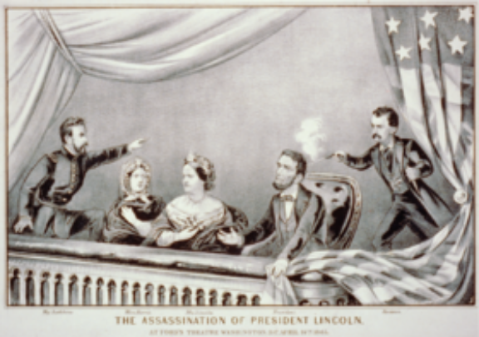

Directions:
- Next to Washington, D.C. draw a gun to represent Lincoln’s assassination.

