Antebellum America
1820-1860
Vocabulary
- Antebellum: literally “_____________ ________ ________”; commonly refers to the time period before the American Civil War during which ___________________ became a major issue
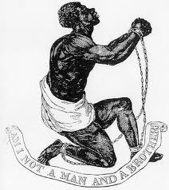
- _______________________________: a person who works to end slavery
Life as a Slave
- Many worked on farms and _______________________ in the South.
- A slave could have many __________ such as…
  - Planting and tending ____________
  - Picking, processing, and loading _______________________
  - _______________________ and repairing buildings and fences
  - _______________________ water
  - Clearing __________
- Living and working conditions were often extremely harsh led by strict “____________________” (slave owners) and slave ____________________.
- Slaves were often deprived of an appropriate _______________________________, like how to read and write.
Fugitive Slave Act (1850)
- The Fugitive Slave Act (from the _______________________ of 1850) required that all ____________________ slaves were, upon capture, to be returned to their masters.
- All officials and citizens of the U.S., including those in ______________ states, had to cooperate with this law.
- Bloodhounds (a type of ___________) were even used to track down runaway slaves.
The Underground Railroad
- Even after the passage of the Fugitive Slave Act, many ____________________________ still wanted to work to end slavery and help slaves escape to their freedom.
- The Underground Railroad was a ________________________ of safe houses where ______________________ slaves could safely stay on their way North or out of the United States.
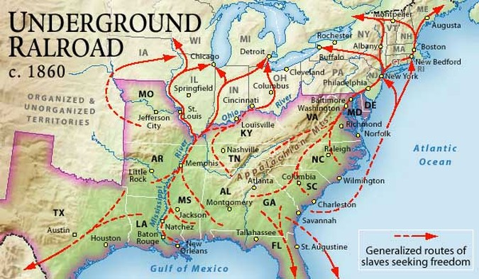

Abolitionist Movements
- Abolitionists had both _____________________ and _____________________ approaches to ending slavery.
  - Literature, __________________, newspapers, peaceful __________________
  - Violent __________________, raids, killings
- However, only a _______________ percentage of freed slaves and Northerners were _____________________.
- Many _______________________ saw the anti-slavery movement leading to:
  - Loss of their ___________ to freed slaves who would work for less money
  - Disruption of the social order (still ____________________________ in North)
  - Further __________________ of the North and South to the point of __________

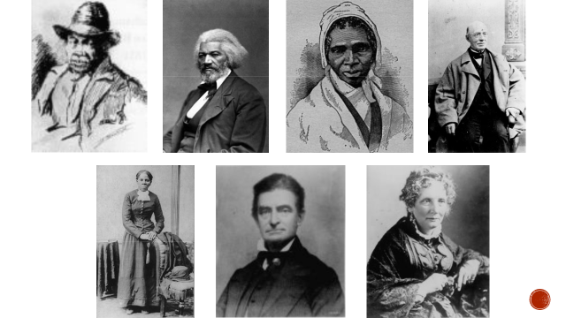
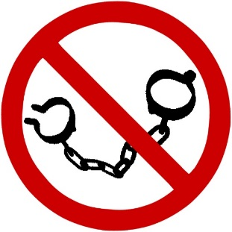

What stands out about the abolitionists pictured above?
_____________________________________________________________________________
_____________________________________________________________________________
_____________________________________________________________________________

