Name: ____________________________ Date: ______________
Brame MYP/Vanguard Texas History Period: _____________

Anglos Settle Texas
Let’s Review!
- First people in Texas are _______________ ________________________.
- Then the __________________ come to explore.
- They build __________________ to keep the French from settling Texas.
- Spain rules Texas and area around it for _________ years…
- …until __________________ get upset with Spanish rule and begin a revolution.
- In ________, Mexico becomes its own country and Texas becomes a ______________________ of Mexico.

Before Mexican Independence in 1821…
- _____________________ were having a hard time getting people to come over from ________________ and live in the _________ _______________.
- They needed people to get their ____________________ running ($).
- Therefore, Spain agreed to let people from the U.S. ( __________________ ) come and settle in Texas.

Empresarios

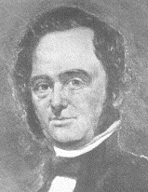
Moses Austin

- ________ – received permission from ____________ to bring Anglos (Americans) to Texas.
- Dies before he can bring Anglos, and then Mexico becomes ________________________________.

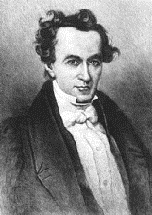
Stephen F. Austin

- ________ – with the help of _________________ _________________ , he asks the Mexican government to honor the promise made by Spain to his father.
- Mexican government agrees and allows him to bring __________ Anglo families to Texas.

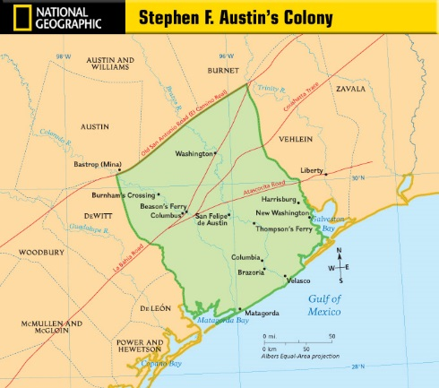
Austin’s Colony
Importance = ________________________________________________

People/families = ____________________________________________

Capital = ____________________________________________________
Reasons for Anglo Settlement
- 12.5 ____________ an acre in Texas vs. ____________ an acre in the U.S.
- _____________________ land for farming/ranching
- Chance to ______________ ___________

Criteria for Austin’s Colony
- Willing to follow ___________________ laws
- Oath of ___________________ (loyalty) to Mexico
- Farmer or ___________________ worker
- ___________________ or silent about other beliefs
- Good ___________________ character
- Hard worker, committed to the ______________
- ___________________ men
- Bringing _______________________ especially welcome!

What do you predict will happen next in Texas history, now that Anglos and Mexicans are sharing the same space?
__________________________________________________________________________________________________
__________________________________________________________________________________________________
__________________________________________________________________________________________________
__________________________________________________________________________________________________

What might the Mexican government do if any Anglo colonists do not follow the settlement criteria upon arrival?
__________________________________________________________________________________________________
__________________________________________________________________________________________________
__________________________________________________________________________________________________
__________________________________________________________________________________________________

