Name: __________________________________ Date: ____________________________
Brame Vanguard/MYP Texas History Period: _________________________

Westward Expansion and Manifest Destiny Notes
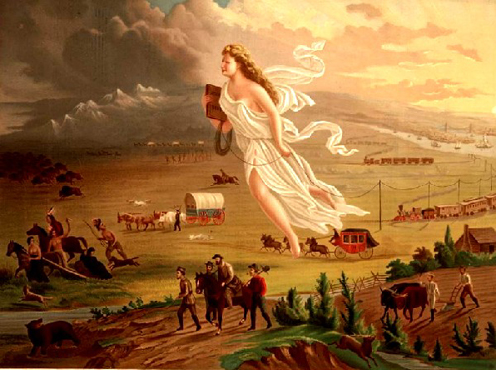
O: _________________________________________
____________________________________________
P: _________________________________________
T: _________________________________________
I: __________________________________________
____________________________________________
C: _________________________________________
____________________________________________
S: _________________________________________
____________________________________________
American Progress – John Gast (1872)

Reasons for Manifest Density:
- Term first coined by John L. O’Sullivan in Democratic Review, July 1845
- Reasons for this belief:
  - Sincere belief in _______________________________
  - Americans viewed the U.S. as a _____________________ for other nations
- The idea of Manifest ______________________ was aligned with ______________________ and ______________________ [extending your country’s power] ideas towards Native Americans and _________________________
- Tied to ________________________ – “God wants our nation to Grow”
  - Less separation of ____________________ and ____________________ (government) during this time period
Population Growth:
- As the United States grew, so did the __________________________________
- In Texas, new/growing groups included…
  - ________________________: South Texas
  - European _______________________________________ (German, Czech, Irish, etc.): Central Texas
  - American _________________________ from the South who brought _________________: East Texas
Why did settlers avoid moving to West Texas? ___________________________________________________
_____________________________________________________________________________________________________________

