Alamo PowerPoint Notes
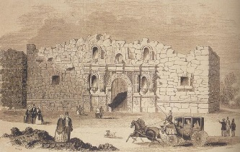
KWL Chart (K= Know W= Want to know L = Learned) – Use the two post it notes to add to the chart on the board. When you are done, come place them on the chart.
1st Post-it – One thing you already know about the Alamo. 2nd Post-it – Two things you want to know about the Alamo.
Warm-up Review:
- What is the first battle of the Revolution? Describe what happened. _______________________________
______________________________________________________________________________________________________________________________________________________________________________________
- How did the Texans perform in the battles that took place in 1835? ________________________________
___________________________________________________________________________________________
- What are some grievances the Texans had with the Mexican government? (at least 3) _______________
______________________________________________________________________________________________________________________________________________________________________________________
- What is the purpose of the Declaration of independence? _______________________________________
______________________________________________________________________________________________________________________________________________________________________________________

History of the Alamo
- The Alamo was a _______________________________
- In the 1700’s it was used to teach ______________________________the ____________________________
- In 1836, it became a huge battleground between ________________________ and ____________________

1) What is a siege? Why would an army use this strategy?

Before the Siege
- Texans gained control of San Antonio in the ____________________________________________
- Never thought _______________________________would bring troops into Texas during the winter
- Santa Anna began assembling troops after the _________________________________________________
- Left Texans _________________________and _______________________________________
- Original Leader of the Alamo was away on family business

The Siege
- On _______________________________________________, Texas Declared Independence
- From ______________ - _________________: Santa Anna led a ______day siege (attack) of the Alamo
- Anywhere from 1,000 to 2,000 (no one knows for sure) Mexicans took on __________ Texans
- Eventually they broke through, killing __________________________ (except the few women and children)
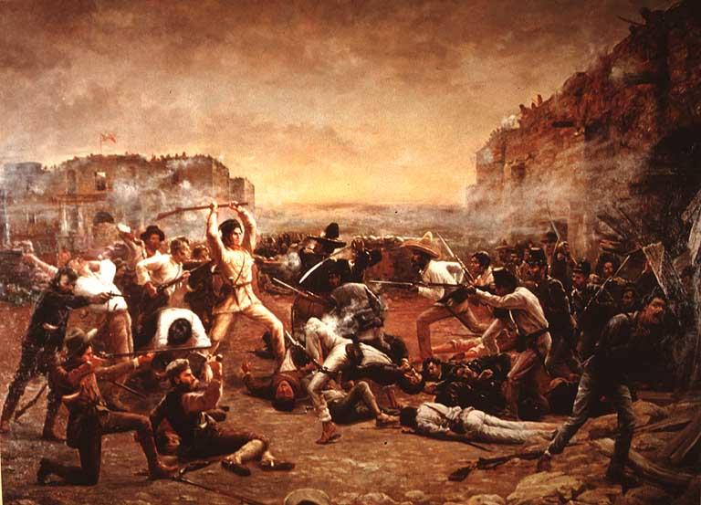
2) Who is William B. Travis? What did he do to cause the Revolution?

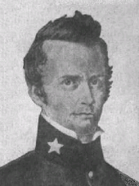
William B. Travis
- The ________________________________ of the Texas army at the Alamo
- Was originally ordered by _______________________ to destroy the Alamo
- “______________________________” And “_____________________________________”
- Kept waiting and hoping for help and reinforcements

James Bowie
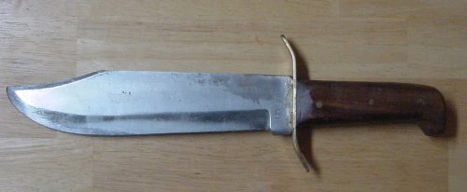
- Leader of the __________________________________ soldiers
- Disagreed with _____________________________
- Was in very __________________________________________________
- Famous “dueler” in Louisiana and Mississippi, made famous this knife:

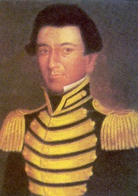
Juan Seguin
- Leader of ________________________ forces, which were Mexicans who joined Texas
- Many Tejano soldiers did not like the dictator ______________________and wanted to fight him
- Was __________________________________in the Alamo, because he was sent with a letter to Sam Houston

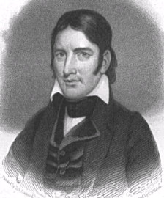
David Crockett
- Congressman from ______________________, brought many volunteers to help Texas
- “_____________________________________________________”
- Crockett and his men were __________________________________________________

3) Even though they lost, why do we remember the Alamo?

Why is this important?
- The __________ knew they would die, but they stayed strong anyway for 13 days refusing to surrender
  - It _________________________________________
- They took out ____________________________________ more Mexican soldiers
  - It __________________________________________
- It held off the Mexican army for __________________ so Sam Houston could gather supplies and soldiers
  - It __________________________________________

