Don’t be a Hater! Be an Abolitionist!

William Lloyd Garrison
Was he a slave?

What efforts did he make to end slavery?

According to Garrison, what was the difference between the North and South?
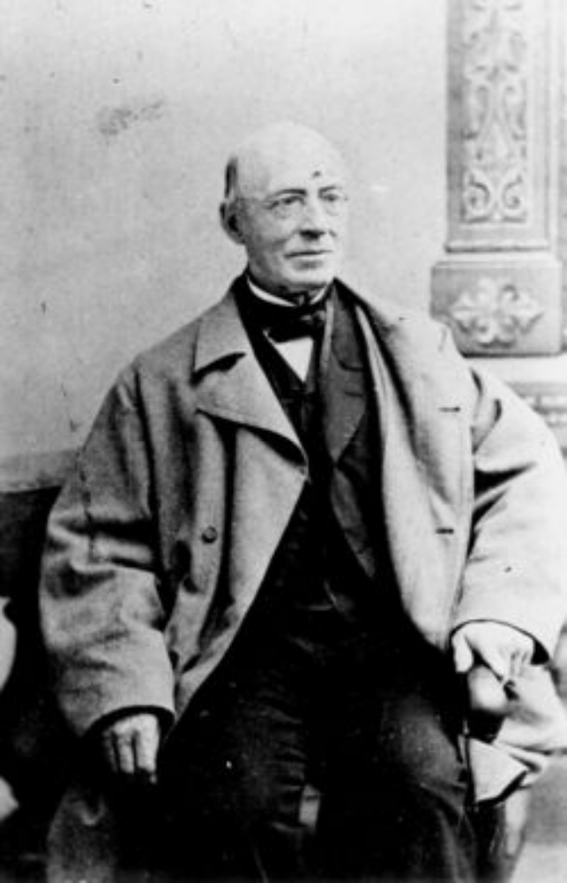

Sojourner Truth
Was she a slave?

What efforts did she make to end slavery?

Why does Sojourner Truth speak out against the focus on African-American men getting their rights?

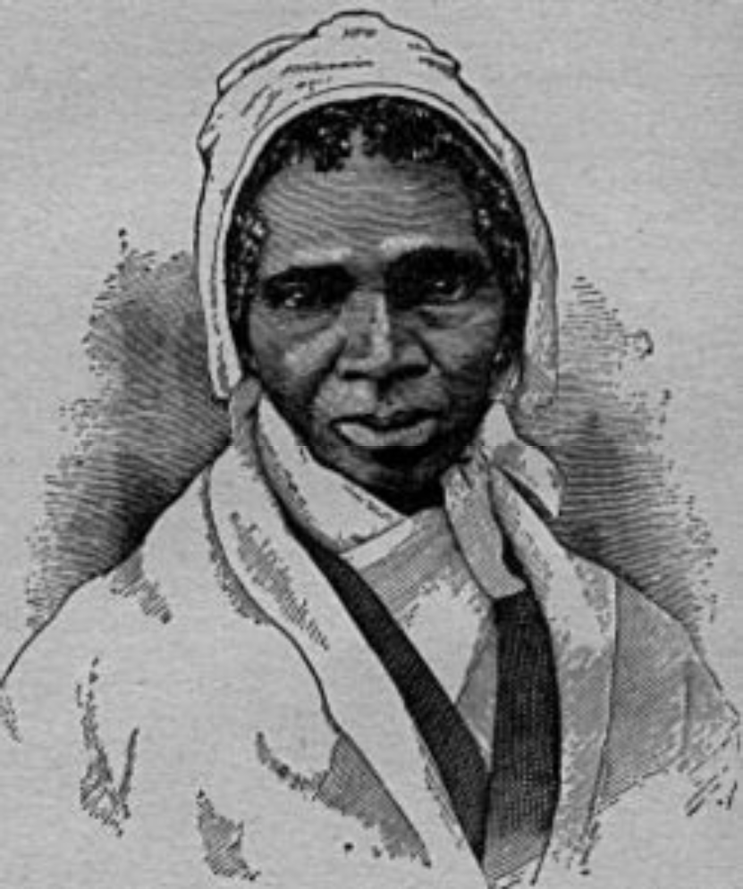

Nat Turner
Was he a slave?

What efforts did he make to end slavery?

Based on the first quote, why do you think Turner committed his crimes? What “crime” is identified in the second quote?

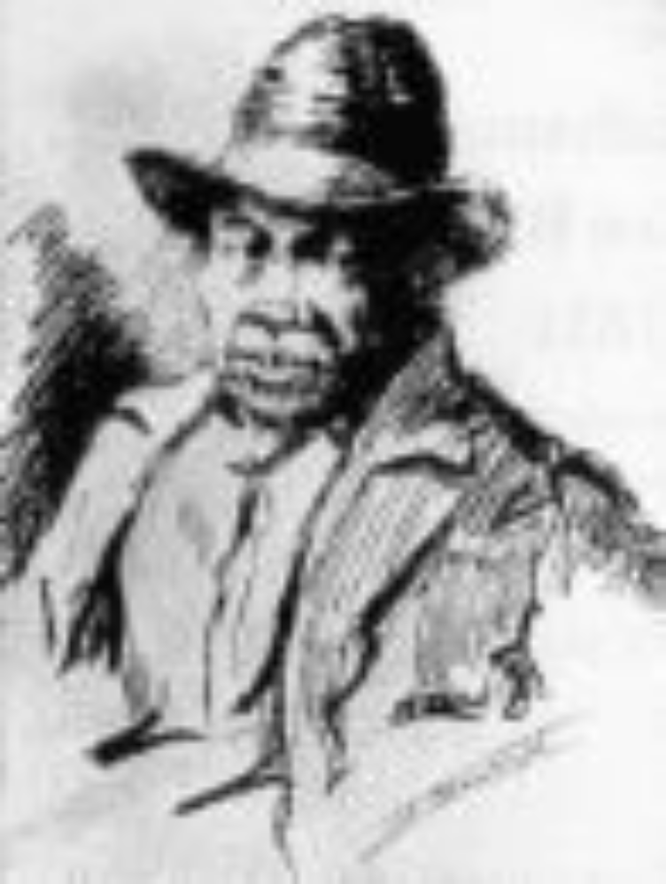

Harriet Tubman
Was she a slave?

What efforts did she make to end slavery?

What is the Underground Railroad from the first quote? Based on the second quote, why do you think many slaves did not try their luck on the Underground Railroad?

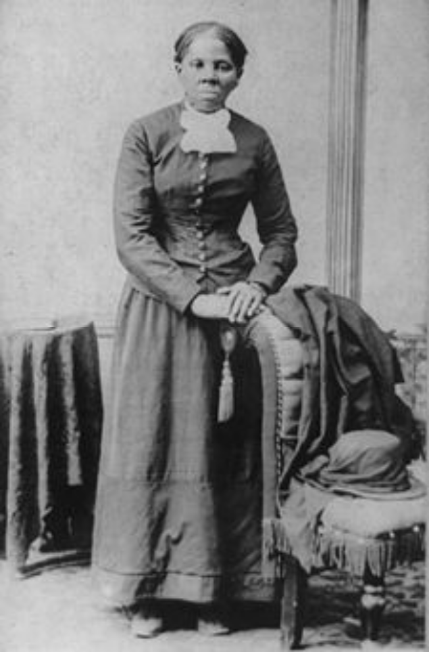
Was he a slave?

What efforts did he make to end slavery?

According to Douglass, what misconceptions did Northerners have about slaves?

Frederick Douglass
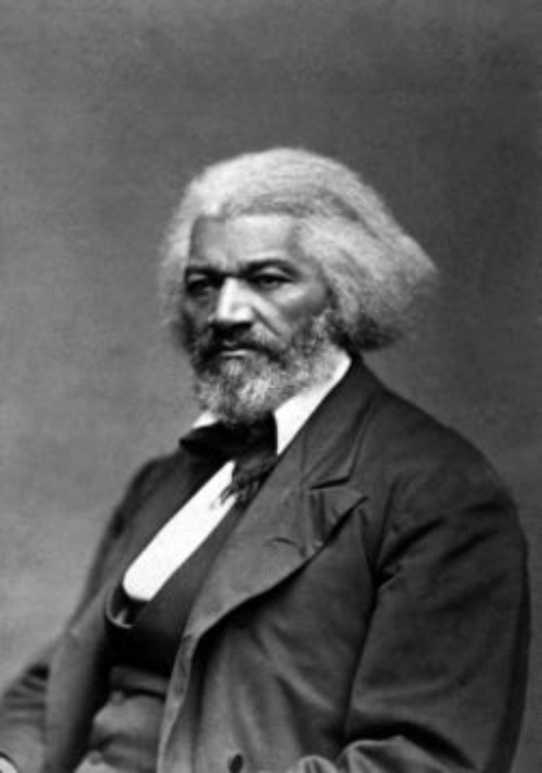
Was he a slave?

What efforts did he make to end slavery?

How did John Brown justify his actions?

John Brown
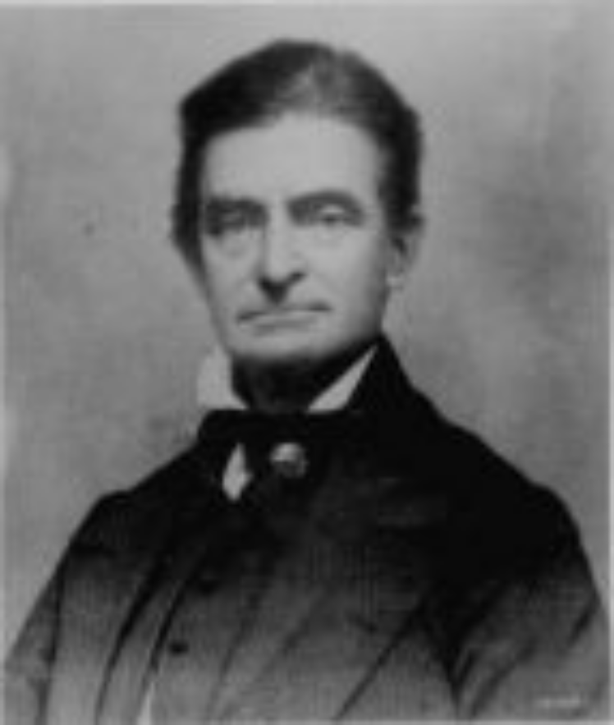

Harriet Beecher Stowe
Was she a slave?

What efforts did she make to end slavery?

According to Uncle Tom’s Cabin, how do you think Stowe viewed the life and rights of a slave?

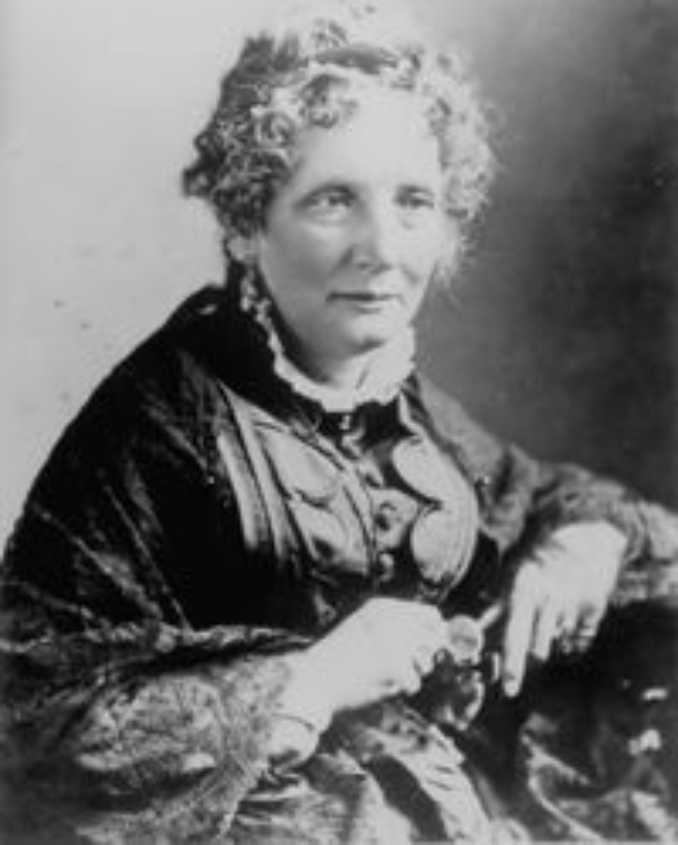

“There is a great stir about colored men getting their rights, but not a word about the colored women; and if colored men get their rights, and not colored women theirs, you see the colored men will be masters over the women, and it will be just as bad as it was before. So I am for keeping the thing going while things are stirring; because if we wait till it is still, it will take a great while to get it going again.”
- Sojourner Truth, 1867, Equal Rights Convention

“You have asked me to give a history of the motives which induced me to undertake the late insurrection, as you call it – to do so I must go back to the days of my infancy, and even before I was born.”
- Nat Turner, 1831, The Confessions of Nat Turner (primary source document)
“It is evil to keep these people in bondage, yet they cannot be freed. They must be educated! To free these people without education and with the prejudice that presently exists against them would be a ghastly crime.”
- William Styron, 1967, The Confessions of Nat Turner (historical fiction)

“I was the conductor of the Underground Railroad for eight years, and I can say what most conductors can't say; I never ran my train off the track and I never lost a passenger.”
“I freed a thousand slaves I could have freed a thousand more if only they knew they were slaves.”
- Harriet Tubman, dates unknown

“I have often been utterly astonished, since I came to the north, to find persons who could speak of the singing, among slaves, as evidence of their contentment and happiness. It is impossible to conceive of a greater mistake. Slaves sing most when they are most unhappy. The songs of the slave represent the sorrows of his heart; and he is relieved by them, only as an aching heart is relieved by its tears. At least, such is my experience. I have often sung to drown my sorrow, but seldom to express my happiness…The singing of a man cast away upon a desolate island might be as appropriately considered as evidence of contentment and happiness, as the singing of a slave; the songs of the one and of the other are prompted by the same emotion.”
- Frederick Douglass, 1845, from Narrative of the Life of Frederick Douglass, An American Slave
“It is unjust that I should suffer such a penalty… Had I so interfered in behalf of the rich, the powerful, the intelligent, the so-called great, or in behalf of any of their friends, either father, mother, brother, sister, wife, or children, or any of that class, and suffered and sacrificed what I have in this interference, it would have been all right; and every man in this court would have deemed it an act worthy of reward rather than punishment.”
- John Brown, 1859, final speech before his execution

“We hear often of the distress of the negro servants, on the loss of a kind master; and with good reason, for no creature on God's earth is left more utterly unprotected and desolate than the slave in these circumstances. The child who has lost a father has still the protection of friends, and of the law; he is something, and can do something, — has acknowledged rights and position; the slave has none. The law regards him, in every respect, as devoid of rights as a bale of merchandise. The only possible acknowledgment of any of the longings and wants of a human and immortal creature, which are given to him, comes to him through the sovereign and irresponsible will of his master; and when that master is stricken down, nothing remains.”
- Excerpt from Uncle Tom’s Cabin by Harriet Beecher Stowe, 1852

“These are solemn times. It is not a struggle for national salvation; for the nation, as such, seems doomed beyond recovery. The reason why the South rules, and the North falls prostrate in servile terror, is simply this: with the South, the preservation of slavery is paramount to all other considerations above party success, denominational unity, pecuniary interest, legal integrity, and constitutional obligation. With the North, the preservation of the Union is placed above all other things – above honor, justice, freedom, integrity of soul, the Decalogue and the Golden Rule – the infinite God himself.”
- William Lloyd Garrison, 1854, “No Compromise with the Evil of Slavery”

Sojourner Truth (1797-1883)
My real name is Isabella Baumfree. I was born into slavery in New York but escaped in 1826 and become officially free in 1827. I worked for the abolition of slavery and for women’s rights. I am best known for my speech, “Ain't I a Woman?” and for fighting to desegregate public transportation.

Nat Turner (1800-1831)
I am a slave who taught myself how to read and write. In 1831, I led a group of slaves on a violent rampage against whites in Virginia. My followers and I killed about 60 whites before we were caught. Fifty-five of us blacks were executed for our part in this rebellion. The whites retaliated by killing more than 200 blacks after our executions.

Harriet Tubman (1820-1913)
My nickname is “Black Moses” because I led a lot of blacks to freedom on the Underground Railroad. I was a slave myself in Maryland but in 1849, I escaped to the North through the Underground Railroad. I made 19 trips back into the South during the 1850s to help other enslaved people escape, risking my own freedom. I helped more than 300 people escape on the Underground Railroad and am, therefore, the most famous “conductor.”

Frederick Douglass (1818-1895)
I am the most widely known African American abolitionist. I was born into slavery in Maryland, taught himself how to read and write, and escaped slavery in 1838. I am a great speaker and traveled all over spreading my antislavery views. I also edited an abolitionist newspaper called the North Star and in 1847, I bought my freedom from my owner.

John Brown (1800-1859)
I am a white abolitionist and believe God chose me to end slavery. In 1859, I led a violent rebellion called the Raid on Harpers Ferry. Nineteen men, both white and black, including myself, raided a storage place for weapons and ammunition. We were trying to get weapons to arm slaves but were caught. I was convicted of treason and hung. Some abolitionists did not support my use of violence while others considered me a hero. Nonetheless, the nation was in uproar when I was executed.

Harriet Beecher Stowe (1811-1896)
Harriet Beecher Stowe was a white writer and abolitionist in Massachusetts. In 1852, she wrote her most famous work about the evils of slavery called Uncle Tom’s Cabin. Her book sold over 300,000 copies in the first year. It was a best seller in the North and banned in the South. Abraham Lincoln was quote saying this to Stowe about Uncle Tom’s Cabin, “You wrote the book that started this great war.”
William Lloyd Garrison (1805-1879)
I am a prominent white abolitionist, journalist, and social reformer. I started my own abolitionist newspaper in Boston in 1831 called The Liberator and founded the American Antislavery Society in 1833. I was one of the first white abolitionists to call for the immediate freeing of slaves.

